FACEBOOK GROUP PARTY – INSTRUCTIONS:
- Create a FB Group (Left Side group (+) Create Group)
- Name the group:
Melissa’s Spa Night w/Mary Kay – Friday, October 22nd at 8pm EST!
- Select “Private” and “Visible”
- Hit “Create”
- Go to Settings and Descriptions:
(copy & paste, change name & date)
❤️ Welcome to Melissa’s Spa Night w/ Mary Kay - Friday, October 22nd at 8pm EST! 💕
You will get a pampering package full of samples to use during the FB Live party! The best part is that you will be in the comfort of your own home in your PJs and no one will see you because it's a FB Live event in this private group!
It's going to be fun, lots of beauty tips and we are giving away prizes.
Please make sure to PM me your mailing address so I can send you a pampering package!
💕Thanks for joining!

- Go to Settings and Customize Group:
Change (name) the Web Address: www.facebook.com/groups/melissamspanight

- Upload FB Cover Photo & replace it

- Add Welcome Post w/2 photo combo (Jen’s selfie & the address request)

MASTER – FACEBOOK PARTY TEXT

About/Description
❤️ Welcome to Melissa’s Spa Night w/ Mary Kay - Friday, October 22nd at 8pm EST! 💕
You will get a pampering package full of samples to use during the FB Live party! The best part is that you will be in the comfort of your own home in your PJs and no one will see you because it's a FB Live event in this private group!
It's going to be fun, lots of beauty tips and we are giving away prizes.
Please make sure to PM me your mailing address so I can send you a pampering package!
💕Thanks for joining!

Post #1 (Hello)
Hello, fellow Beauty Lovers! My name is Jen Besecker and I will be your Mary Kay consultant for Melissa's Spa Night!
The party will actually take place on Friday, October 22nd at 8pm on Facebook (in this group), I will be going LIVE! You will be receiving a pampering package full of samples to use during the LIVE.
I’ll be posting a couple of pre-party posts that will help you get acclimated and also give you chances to be entered into a drawing to win FREE PRODUCT DRAWING!
Anytime you see a comment on that post and you’ll get entries for that drawing! Comment "HI" below to get your first entry!
Here are 5 things:
Send me your mailing address
Reply to any post with a
Sit back, relax and check in daily to be entered to win FREE STUFF!
Join us on 10/22 at 8pm (EST) in this group for the FB Live Pampering party!
SHARE SHARE SHARE!!! Invite your friends to join us! For each friend that you invite, tag her name below and you get an entry for every friend. 💕

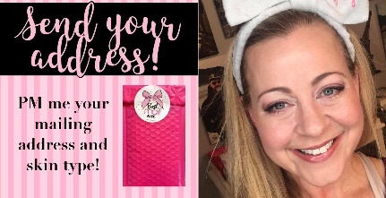

WELCOME: – (post when new members join)
Welcome and thank you for joining _______'s party!
Please make sure to send me your address so I can mail you a pampering package full of samples for the FB Live party on 10/22 at 8pm! Thanks!
(TAG NAMES) and change up welcome photo
About/Description – for LAUNCH PARTIES
❤️ Welcome to Lindsay’s Mary Kay Launch Party - Friday, November 5th at 7pm EST! 💕
You will get a pampering package full of samples to use during the FB Live party! The best part is that you will be in the comfort of your own home in your PJs and no one will see you because it's a FB Live event in this private group!
It's going to be fun, lots of beauty tips and we are giving away prizes.
Please make sure to PM Lindsay your mailing address so I can send you a pampering package!
💕Thanks for joining!

Post #1 (Hello) – For LAUNCH PARTIES
Hello, fellow Beauty Lovers! Welcome to Lindsay's Mary Kay Launch Party! My name is Jen Besecker and I will be partnering with Lindsay to pampering you!
The party will actually take place on Friday, November 5th at 7pm on Facebook (in this group), I will be going LIVE! You will be receiving a pampering package full of samples to use during the LIVE. Please let Lindsay know your address.
I’ll be posting a couple of pre-party posts that will help you get acclimated and also give you chances to be entered into a drawing to win FREE PRODUCT DRAWING!
Anytime you see a comment on that post and you’ll get entries for that drawing! Comment "HI" below to get your first entry!
Here are 5 things:
Send Lindsay your mailing address so we can mail you a pampering package full of samples to use during the FB Live Party!
Reply to any post with a
Sit back, relax and check in daily to be entered to win FREE STUFF!
Join us on 11/5 at 7pm (EST) in this group for the FB Live Pampering party!
SHARE SHARE SHARE!!! Invite your friends to join us! For each friend that you invite, tag her name below and you get an entry for every friend.
WELCOME (LAUNCH): – (post when new members join)
Welcome and thank you so much for joining _____'s Mary Kay Launch party!
Please make sure to send ______ your address so we can mail you a pampering package full of samples to use during the FB Live party on 11/5 at 7pm! Thank you!
Let's welcome our new members:
(TAG NAMES) and change up welcome photo
Post #2 (Love my Host) – (post 1 week before party)
What do you love about Melissa McHarg our hostess with the mostess?
Comment below for 5 tickets into a prize drawing on the FB Live Party on 10/22 at 8pm!
Please make sure to PM me your address so I can send you a pampering package full of samples to try during the FB Live event.
(Tag invites)
FB Messenger/Email: (address reminder to invitee)
Hi __ - Thank you for joining Melissa's Spa Night on 10/22. My name is Jen Besecker and I'm the beauty consultant for her party. I would love to send you a pampering package full of samples to use during the FB Live party on 10/22 at 8pm EST. Can I please get your address?
Thank you for your address - Samples Sent:
Good morning thank you so much for your information. It’s nice to meet you virtually. A pampering package is on the way.

HOSTESS INVITE (EMAIL) REMINDER:
Hi gorgeous! I’m very excited about your upcoming party. Great job on sending out the invites. I noticed that you already have _ people coming, that’s fantastic! And _pending invitations.
In order for me to make sure everyone receives their sample packets on time, will you do me a favor? Can you send those pending invites each a personal message through Facebook messenger or a text inviting them with the link? I’m confident that many of them missed seeing your invite because there is a lot of info going on in Facebook & everyone has busy lives. So, I would love for them to be included. Thank you so much. Looking forward our virtual party! Here’s a message you can send to them.
I’m hosting a Mary Kay Virtual FB Party! I hope you can join. You will receive a pampering package to use during the Live.
Click here to join: __ link

JEN’S CALENDAR DETAILS CHECK LIST:
To Do - made FB page
To Do - Post #1 (Hello)
To Do - Welcome (tag names) post x1
To Do - Post #2 (love my host)
To Do - Need to send samples
To Do - Hostess Invite Reminder (I sent her a voice message about it)
KEEPING TRACK OF PARTY GUESTS IN ABC ORDER & SAMPLES SENT:
(CREATED IN GOOGLE DOC)
Melissa McHarg’s Spa Party: Addresses
Friday, October 22, 2021- 8pm EST
Sample pampering packages for Melissa’s Spa party!

💓 (Host) Melissa Mautz McHarg
533 Higgins Dr
Odenton, MD 21113-2001

👍 Kelly Helm-Bacon
2422 Flowering Tree Lane
Gambrills MD 21054-1409
⛔ Lindsay Freisthler
Waiting for address
City, State, zip

💬 Lisa Talbot
Waiting for address
City, State, zip
*sent email 10/9/21

💬 Name
Waiting for address
City, State, zip
*send email 10/9/21

💓sent
👍 ready to send
💬 waiting for address
⛔ Do NOT send (consultant)

FACEBOOK PRIVATE MESSAGE:
Hi __ - Thank you for joining Melissa's Spa Night on 10/22. My name is Jen Besecker and I'm the beauty consultant for her party. I would love to send you a pampering package full of samples to use during the FB Live party on 10/22 at 8pm EST. Can I please get your address?
*sent emails 10/9/21

RESPONSE:
Thank you so much for your information. It’s nice to meet you virtually. A pampering package is on the way.

PM REMINDER:
Hi Guest - I'm just checking back in to see if you would like a pampering package for Melissa's party. 🙂

MIRACLE SET PARTY SCHEDULE POSTS:
I normally do 2 postings per day a week to 10 out from the party!
Post #1:
Hi everyone! Thanks again for joining Jane Doe’s party!
𝘾𝙤𝙢𝙢𝙚𝙣𝙩 𝙗𝙚𝙡𝙤𝙬 on 𝙝𝙤𝙬 𝙮𝙤𝙪 𝙠𝙣𝙤𝙬 Jane why you love her!!!
P.S. Every comment throughout the party gets you entered to win free products

Post #2:
It’s hot for me! How about you?!?!

Post #3:
Which one would you love for FREE?
LET’S TALK EXFOLIATION!!!
Are ya doing it?! If not, you’re missing a crucial part in your skincare, and an important piece to making your makeup look good. Exfoliating helps your other skincare products be able to absorb more and work better!
I’m gonna show you our starting lineup, I use all 3 of these products!!
1) Skinvigorate Brush: use twice daily
Using your daily cleanser, this brush gets your face 95% cleaner than you can get it with your hands or a washcloth!! It really gives you that relaxing spa feeling too, and it totally made my face GLOW when i started using it. SQUEAKY clean!
2) Microdermabrasion: use 1-2 times weekly
This is a physical exfoliator that takes off the entire top layer of skin; aka all the dead skin and layers of dirt/makeup! It removes old acne marks and scars, reveals all fresh new skin, helps even out skin tone, improves the skin’s texture, and brightens dull complexions. Great for melasma and age spots!
3) Radiance Reveal Peel: use 1-2 times weekly
- This is a chemical exfoliator that won’t leave you red, irritated and in pain! It goes DEEP to remove dead cells using Glycolic Acid. Skin will be left looking brighter, fine lines and wrinkles will be reduced, and skin will be overall smoother and tighter! Great for dark spots as well.

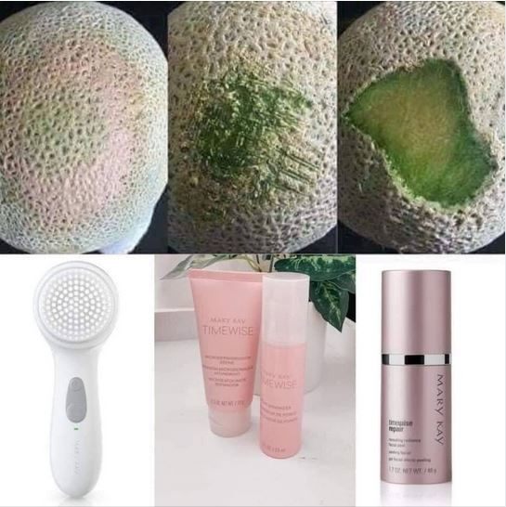

Post #4:
Are you a Matte or Glossy girl?
(Tag Names)

Post #5:
Watch the videos and comment below which skincare set you would benefit the most from.
Mary Kay has created sets to make your skincare routine as simple as 1, 2, 3! Find which skincare set is best for you. Select the link for the skincare regimen that BEST describes your needs!
Naturally Skin Care: http://vid.us/6l1aqn
Repair Set: http://vid.us/z9d7mh
TimeWise Miracle Set 3D: http://vid.us/fqpdjq
Clear Proof: http://vid.us/n0okzd
Botanical Effects Skincare: http://vid.us/koi4jm
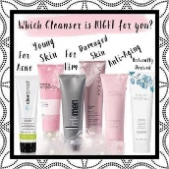

Post #6:
Comment below if you would like to try these
Pack Your Bags ladies!
Pack. Your. Bags.
Undereye Bags that is!
Mary Kay's hydrogel patches are AMAZING!
Here’s how they work:
Step 1: Put them under your eyes (you can also use them other areas as well; refer to the graphic below!!)
Step 2: Wait 20 minutes
Step 3: Remove them and lose your mind at how good you look!!
And there are 30 pairs in a jar!!!
Goodbye fine lines & wrinkles
Goodbye puffiness
Goodbye under-eye circles
Goodbye Bags!
Hello lift
Hello moisture
- Hello smooth
- Hellooooo brighter skin
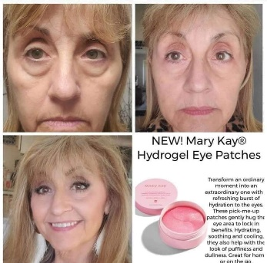

Post #7:
Love YOUR Lashes!
Comment below for a prize drawing entry.
Many of you ask which mascara do I wear...LASH INTENSITY!
Watch this fun video explaining how to use it. http://vid.us/fcgpe7
What do you look for when picking a mascara?...
-volume
-lengthening
-defining
-waterproof
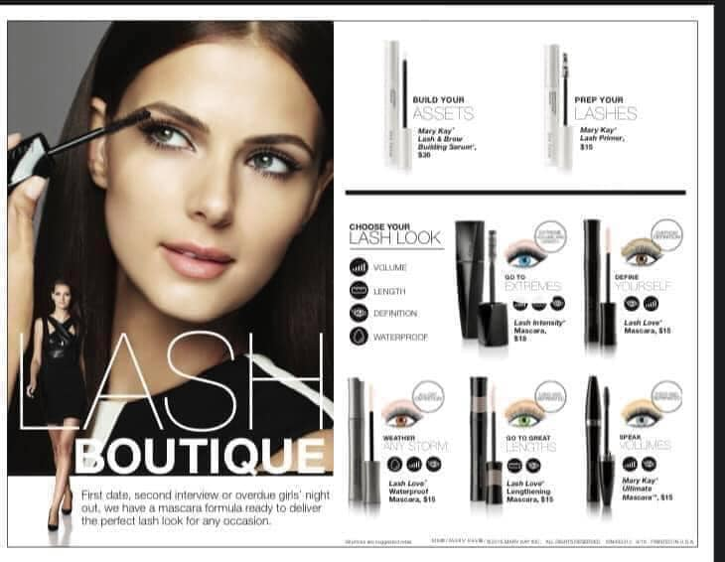

Post #8:
Comment your favorite color of lipgloss below you would love to try and get for FREE!!!!!
(Tag Names)
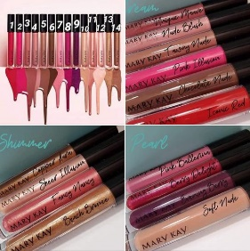
Post #9:
Are you a skin care girl or a glamour girl?
Comment “THIS” or “THAT” for an entry into our prize drawing!
I’m a totally “THIS” skin care girl!
(Tag Names)
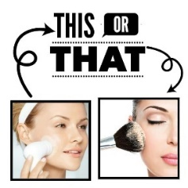

Post #10:
Here is another one of my favorite products! Deep Line Wrinkle Filler!
DEEP. WRINKLE. FILLER.
I am obsessed!
It is basically Botox in a pen!!! The retinol plumps up the wrinkle to fill it in instantly right before your eyes but also helps fill them in permanently over time as well!!!
It’s a targeted wrinkle product so you just put this specifically where you need it, not your whole face. This is very beneficial even to young women who may just have one forehead wrinkle.
Who needs this?!?
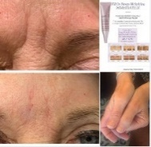

Post #11:
Which would you choose? Fragrance-Free or White Tea & Citrus?
This three-step, spa-like treatment revitalizes and rejuvenates the look of hands, so they feel renewed and instantly look healthier.
Instantly, hands feel moisturized, soft and smooth.
•Satin Hands® Satin Smoothie®
•Refining Shea Scrub
•Satin Hands® Nourishing Shea Cream pamper hands with shea butter.
(Tag Names)
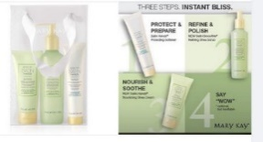
Post #12:
**PRODUCT SPOTLIGHT**
𝐋𝐄𝐓’𝐒 𝐓𝐀𝐋𝐊 𝐌𝐈𝐂𝐑𝐎𝐃𝐄𝐑𝐌𝐀𝐁𝐑𝐀𝐒𝐈𝐎𝐍!
Do you know how much a peeling or microdermabrasion session costs for your face at a Spa?
$150 to $300 on average per 1 treatment depending on the place you go & in order for the best results from this treatment they ask you to go a minimum of once a month for 3 months!
Microdermabrasion is a physical exfoliating process that reduces the appearance of fine lines and gently refines skins texture as it removes surface dead skin cells and build-up from pores.
Get the look of polished, younger skin and significantly smaller pores with our Microdermabrasion Plus Set and 𝐬𝐩𝐞𝐧𝐝 𝐚 𝐥𝗼𝐭 𝐥𝐞𝐬𝐬 for the 𝐬𝐚𝗺𝐞 results.
𝐒𝐭𝐞𝐩 #1, 𝐌𝐢𝐜𝐫𝗼𝐝𝐞𝐫𝗺𝐚𝐛𝐫𝐚𝐬𝐢𝗼𝐧 𝐑𝐞𝐟𝐢𝐧𝐞:
is a physical exfoliator that reduces the appearance of fine lines and gently refines skin’s texture as it removes surface dead skin cells and build-up from pores. It has the same aluminum oxide crystals that you would get at the dermatologists office.
𝐒𝐭𝐞𝐩 #2, 𝐏𝗼𝐫𝐞 𝐌𝐢𝐧𝐢𝗺𝐢𝐳𝐞𝐫:
goes beyond skin texture to tighten the look of pores. With pores cleared of build-up and dead skin cells, Pore Minimizer works immediately to reduce their appearance. And the results get better over time. The Pore Minimizer nourishing serum helps calm and comfort skin. It’s the perfect after-step to Microdermabrasion Refine to reduce any appearance of redness and soothe delicate skin. Working together 2-to-3 times a week, both products dramatically improve skin texture for a high-definition-worthy complexion.
𝐓𝐇𝐄 𝐒𝐂𝐈𝐄𝐍𝐂𝐄 𝐁𝐄𝐇𝐈𝐍𝐃 𝐓𝐇𝐄 𝐏𝐑𝐎𝐃𝐔𝐂𝐓𝐒:
Congested pores can lead to stretching of the pore wall, making them look enlarged. Eliminating impurities trapped within is an important first step toward improving their appearance.
Persian silk tree bark extract and soy bean extract in Pore Minimizer are shown to support factors important to skin +, which may help tighten the look of skin overall and around pores.
Skin calming and comforting benefits on skin’s surface provided by Pore Minimizer are assisted by sea whip extract and evodia fruit extract. These two ingredients have been shown to support signals associated with skin calming and + comfort. Visible results in one week!
Just look at these results!!
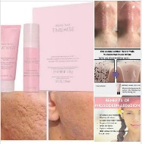

Post #13:
Invest in your skin! Check out our 5 different skincare line! Which one do you think is best for your skin?
TICKET TIME
There are 8 things studies tell us that women want to improve about their skin.
What are yours?
Uneven skin tone
Oiliness
Dryness
Fine Lines and Wrinkles
Texture
Blackheads/Acne
Dullness
Firmness
Post below your biggest skincare concern for an extra ticket into our drawing!
(Tag Names)
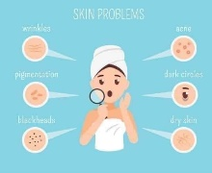
Post 14:
TimeWise Body Targeted-Action Toning Lotion
Toning Lotion helps redefine body contours by toning, firming and smoothing your entire shape in just one step. Its skin-loving formula contains six antioxidants, including Acai Berry Extract. The powerful mix of ingredients, including multiple botanicals, targets areas of concern and keeps skin hydrated for up to 24 hours. Maintaining skin hydration is even more important as you age. In addition to improving how soft and smooth skin feels, skin that’s effectively moisturized can actually look smoother, which means the appearance of imperfections can be less noticeable.
Check out these amazing before & after pics!

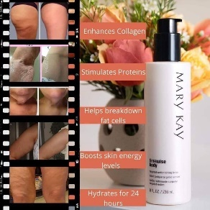
Post Day Before Party: – at 8am)
Who is excited for you to try our Timewise 3D skincare regimen tomorrow night at HOST NAME party at 8pm? Comment below for 5 extra tickets!
It is great for women wanting to combat the early signs of aging. It comes in a “Normal to Dry” formula and a “Combination to Oily” formula. Check out these amazing before & after pictures of the model using our 3D line! The results are AMAZING!!
*BONUS: If you add our awesome Microdermabrasion Refine & Pore Minimizer set to our Timewise 3D miracle set, you've got the “Ultimate Miracle Set”!!!
(Tag Names)
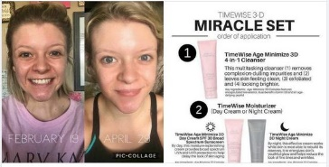
Post Day Before Party: – at 8pm)
I'm super excited for Jane Doe’s FB Live party tomorrow night at 8pm! Below is a list of things to have ready for the fun pampering party! Tons of fun and prizes giveaways!
Comment below for an extra ticket if you will be joining us on the FB Live party tomorrow night at 8pm!
(Tag Names)
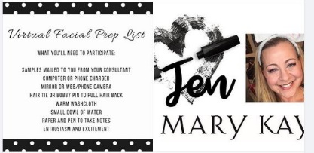

Party Day Post: (party day – at 8am)
Comment below This or That! I'm excited for HOST’S NAME FB Live Party tonight at 8pm!
Would you prefer the deep pore cleansing power of the activated charcoal mask, this? OR
The intense hydration of the Moisture Renewal Mask, that?
(Tag Names)
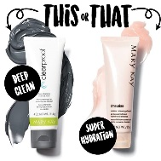

Party Day Post – at One Hour Before Party- 7 pm)
Only one more hour and it’s pampering time! See you here at 8pm for Facebook Live
INTERACTIVE POSTS:
Love Post:
What do you love about Jane Doe our hostess with the mostess?
Comment below for 5 tickets into a prize drawing on the FB Live Party on 2/1 at 7pm!
Please make sure to PM me your address so I can send you a pampering package full of samples to try during the FB Live event.
(Tag Names)

Something Good:
Check-in daily for any post with a
These posts will get you entered into a prize drawing!
2021 has been interesting to say the very least! Tell me something GOOD that has happened!?
(Tag Names)
Post:
Let me know below for a ticket into the prize drawing!
(Tag Names)
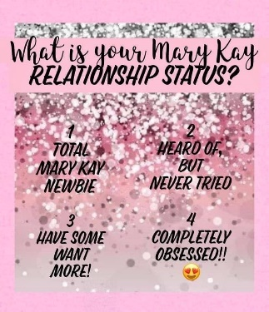

Post:
- Comment below with your favorite!

DAYS OF THE WEEK POSTS:
Monday:
Monday MVP
The Tone Correcting Serum! It took 10 years of development to harness the power of the Navy Bean, but so worth it! This patented formula not only brightens the appearance of your skin, but helps with hyperpigmentation, dark spots, and sun damage- leaving you with a noticeably more even skin tone with consistent use. Appropriate for every skin tone and type, this formula is super light and leaves you more confident in your skin- even without makeup!
Would you like to try it??
(3 pics below & change day of the week)
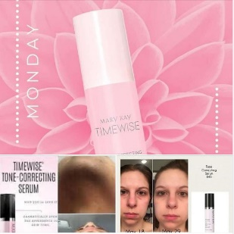

Tuesday:
It’s Taco Tuesday!
- Do you prefer Hard or Soft
(Tag Names)

Wednesday:
Wednesday Wisdom: One of My Favorite Things is our Undereye Corrector.
Many women make the mistake of putting regular concealer under their eyes. If you have ever tried this you may notice that it seems to just highlight the area rather than conceal the dark circles. For extreme dark circles, you can use the corrector and then put the concealer on top. (I have found that the Hydrogel Eye Patches and Undereye Corrector is a magic combo).
The dark circles are neutralized by a peach-toned corrector. Do this after your foundation and watch the circles disappear PLUS your eye area will look more lifted & you'll get a more youthful look.
Wondering how to shop?? You can place an order 1 of 3 ways:
1) Message me on Facebook messenger
2) Go straight to the website: www.marykay.com/JenSemelsberger (all discounts will be taken off before card is processed)
3) Good Ol' Fashion; call, text or email; 301-922-7038 mk@jenbesecker.net
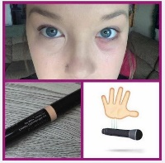

Thursday:
It's Thursday Thankful, and today I am so thankful for my Indulge Soothing Eye Gel!
This little jar is jam packed full of antioxidants, soothing agents, and skin conditioners to help de-puff, tone, and firm your eye area. You can use this little jar throughout the day- and on top of your makeup!- to help keep puffiness at bay while you're looking more awake and bright! Tired, allergies, emotional movie? The Indulge Soothing Eye Gel has you covered!
Pro Tip: keep it in the fridge for added cooling benefits!
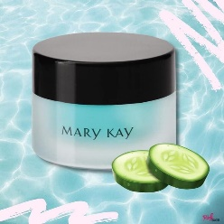

Friday-1:
How do trees get online?
They just log on!
If you love all things natural and prefer that your skincare does too, you may LOVE Mary Kay's Naturally skincare line! Not only is everything Certified Natural by EU standards (the strictest in the world), but it's also a really cool and unique take on what you need from your skincare steps! The fan favorite Nourishing Oil is TOP, the Exfoliating Powder is fabulous and multi-use, the portable Moisturizing Stick goes with you everywhere, and the Cleanser is a delightful natural clean! Mix and match with other Mary Kay skincare, or use as its own set - you're going to LOVE it!.

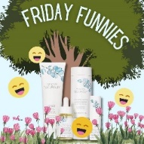
Friday-2:
Singing in the shower is fun until you get soap in your mouth.
Then it's a soap opera!
Are you a shower singer or a shower thinker? Are you more body wash or bar soap? Or cleanser or bar soap? For all my bar soap people out there- you're not alone and I have something for you! The TimeWise Beauty Bar has our fabulous TimeWise technology in the bar form that you know and love! Hooray!!!

Friday or Saturday PM Post:
Do you prefer red wine or white wine?!?! Red for me!
FALL TIME POSTS
Fall – Lip gloss: Post
GO NUDE this season!
Fall is just around the corner and so is cooler weather (unless you live in the Sunshine State). I don’t know about you, but autumn makes me in the mood for pumpkin spice lattes, cute boots and knit sweaters! When the leaves change colors and begin to fall it’s time to hang the autumn wreaths and decorate with pumpkins. It’s also time to change up your skincare and glamour routine.
- Look at this beautiful lipgloss shade...Tawny Nude!
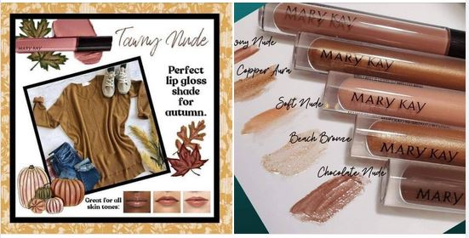

(FALL) Party Day Post: (Morning of Party Day)
Happy Fall
- Game time!!! Winner to be picked once we make it through the alphabet. If we get to Z, start over with A. Every comment will get you an entry on the random wheel!
(Link party name)

Candy Post:
What are your favorites? I love Snickers & Almond Joy

Halloween Post:
PARENTS: Do you spend Halloween night or the following morning scrubbing your kids' face until they cry?? For easy makeup removal.... Grab some MK Oil-Free Eye Makeup Remover! Yes, it IS for the eyes BUT, if it's gentle enough for the eyes, the whole face (and body) can use it as well!
Halloween makeup can stain the skin and can be really hard to remove from the skin without a little pain.
SO...... Do yourself a favor! Use a little PRIMER under ANY and ALL Halloween makeup this year!
The Primer will help create a layer of protection on the skin so the makeup is easy to remove without painful scrubbing!
For EXTREME cases: If makeup is not lifting off skin easily, apply Intense Moisturizing Cream to the area, allow a warm wet cloth to sit over top and gently wipe off! Reds can be a PAIN to remove!
Have a happy and safe Halloween everyone!

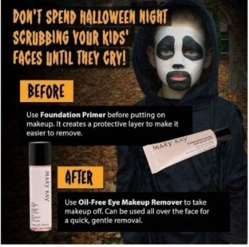

Interactive: Thanksgiving Posts
If you could only pick one, what would it be?!?! Pecan for me! !!!

WINTER TIME POSTS
Satin Lips (Winter)
Exfoliation is a MUST, especially in the winter! Satin Lips! Special deal on Satunf Lips announced tonight during the party!!!
Who has dry lips this winter?
We exfoliate our face and body, we can't forget about our lips
The Satin lips set is a product for everyone-- women, men, even kids!
Put on the shea sugar scrub for 1-2 minutes, wash it off and apply the shea butter balm for a moisturized smooth feel!
The scrub can be used as needed, and the balm can be used everyday! I love that it shows the true color of your lips and can be applied over a lipstick for more moisture!
Wondering how to shop?? You can place an order 1 of 3 ways:
1) Message me on Facebook messenger
2) Go straight to the website: www.marykay.com/JenSemelsberger (all discounts will be taken off before card is processed)
3) Good Ol' Fashion; call, text or email; 301-922-7038 mk@jenbesecker.net
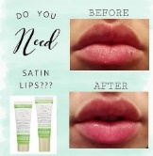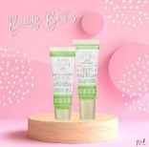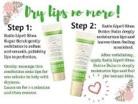

Winter or Holiday Game Post (Morning of Party Day):

It's Wintertime!
Game time!!! Winner to be picked once we make it through the alphabet. If we get to Z, start over with A. Every comment will get you an entry on the random wheel!

Lips (Valentines)
Valentine's Day is coming!! Get those lips ready or surprise your loved ones with some of Mary Kay's lip smacking gifts

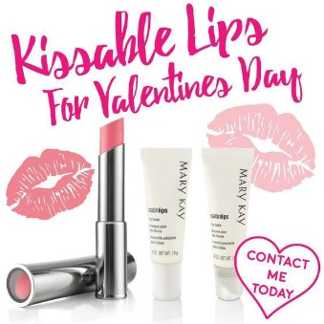

TIMEWISE REPAIR (TURN BACK TIME) PARTY SCHEDULE POSTS
Welcome Post #1: (Day 1)
Welcome again to Host Name's party!
Check-in daily to this FB Group for any post with a
These posts will get you entered into a prize drawing!
Comment below that you have seen this message and get 5 tickets!
(Tag Names)
Post #2:
Are you a skin care girl or a glamour girl?
Comment “THIS” or “THAT” for an entry into our prize drawing!
I’m a totally “THIS” skin care girl!
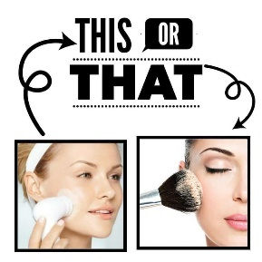

Post #3:
Comment your favorite color of lipgloss below you would love to try and get for FREE!!!!!
(Tag Names)

Post #4:
TimeWise Replenishing Serum C + E
Give skin its daily dose of essential vitamins with this powerful blend of C + E. Vitamin E is one of the most powerful antioxidants known to science. When paired with vitamin C, it receives a boost that reignites its defense against skin aging. Daily use delivers skin that’s firmer, brighter — glowing with good health.
This serum’s exclusive, patent-pending complex provides the benefits of three distinct and efficacious sources of vitamin C. This trio helps ensure the age-fighting action of vitamin C on the skin.
We all know that vitamin C is great for your skin, but so is vitamin E. Vitamin E is a highly potent antioxidant that is critical for protecting your skin against premature aging caused by free radicals. When it’s paired with vitamin C, it gets a boost that reignites its age-fighting power. These two skincare superheroes are effective alone, but they’re extraordinary together!
This new formula is made with 3 sources of vitamin C, including pure vitamin C, amla fruit extract and an oil-soluble vitamin C derivative. This new multifunctional formula also includes Mary Kay’s proprietary ingredient of navy bean extract, which has a remarkable ability to brighten skin!
This is truly the perfect upgrade to your routine.
In just four weeks, you’ll notice more resilient, radiant skin and greater results over time!
Glow forth with TimeWise Replenishing Serum C+E
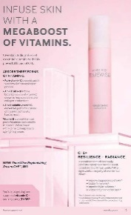

Post #5:
Which one would you love for FREE?
LET’S TALK EXFOLIATION!!!
Are ya doing it?! If not, you’re missing a crucial part in your skincare, and an important piece to making your makeup look good. Exfoliating helps your other skincare products be able to absorb more and work better!
I’m gonna show you our starting lineup, I use all 3 of these products!!
1) Skinvigorate Brush: use twice daily
Using your daily cleanser, this brush gets your face 95% cleaner than you can get it with your hands or a washcloth!! It really gives you that relaxing spa feeling too, and it totally made my face GLOW when i started using it. SQUEAKY clean!
2) Microdermabrasion: use 1-2 times weekly
This is a physical exfoliator that takes off the entire top layer of skin; aka all the dead skin and layers of dirt/makeup! It removes old acne marks and scars, reveals all fresh new skin, helps even out skin tone, improves the skin’s texture, and brightens dull complexions. Great for melasma and age spots!
3) Radiance Reveal Peel: use 1-2 times weekly
- This is a chemical exfoliator that won’t leave you red, irritated and in pain! It goes DEEP to remove dead cells using Glycolic Acid. Skin will be left looking brighter, fine lines and wrinkles will be reduced, and skin will be overall smoother and tighter! Great for dark spots as well.

Post #6:
TimeWise Body Targeted-Action Toning Lotion
Toning Lotion helps redefine body contours by toning, firming and smoothing your entire shape in just one step. Its skin-loving formula contains six antioxidants, including Acai Berry Extract. The powerful mix of ingredients, including multiple botanicals, targets areas of concern and keeps skin hydrated for up to 24 hours. Maintaining skin hydration is even more important as you age. In addition to improving how soft and smooth skin feels, skin that’s effectively moisturized can actually look smoother, which means the appearance of imperfections can be less noticeable.
Check out these amazing before & after pics!

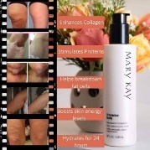
Post #7:
Comment below if you would like to try these
Pack Your Bags ladies!
Pack. Your. Bags.
Undereye Bags that is!
Mary Kay's hydrogel patches are AMAZING!
Here’s how they work:
Step 1: Put them under your eyes (you can also use them other areas as well; refer to the graphic below!!)
Step 2: Wait 20 minutes
Step 3: Remove them and lose your mind at how good you look!!
And there are 30 pairs in a jar!!!
Goodbye fine lines & wrinkles
Goodbye puffiness
Goodbye under-eye circles
Goodbye Bags!
Hello lift
Hello moisture
- Hello smooth
- Hellooooo brighter skin

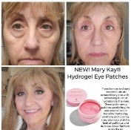
Post #7:
Love YOUR Lashes!
Comment below for a prize drawing entry.
Many of you ask which mascara do I wear...LASH INTENSITY!
Watch this fun video explaining how to use it. http://vid.us/fcgpe7
What do you look for when picking a mascara?...
-volume
-lengthening
-defining
-waterproof

Post #8:
How much “support” do you need?
Everyone will receive a sample of our 3D eye cream!
Comment below for an entry in the raffle!
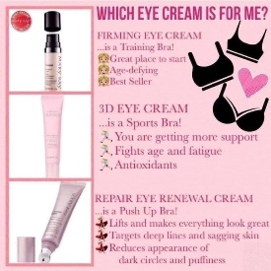
Post #9:
Getting vulnerable here... anyone else struggle with dark spots, sunspots, or uneven skin tone?!!
I should have taken a picture sooner but LOOK AT MY PERSONAL RESULTS!!
No expensive treatments at the spa needed. Just my Mary Kay
The sun can do uglyyy things to our beautiful skin.
I grew up in the sun wakeboarding and unfortunately I’ve only started really protecting my skin with SPF on a daily basis this past year and a half
I am religious about skin care routine, BUT I was sick of these ugly dark spots and wanted to kick it up a notch and get rid of them quickerrrrrr.
I started adding in Mary Kay’s:
-Vitamin C serum
-Tone correcting serum
-Repair Night cream with retinol on a regular basis.
(While still staying loyal to my current skin care routine)
And adding in the Mary Kay Revealing radiance facial peel with Glycolic acid, on top of the charcoal mask & microdermabrasion treatment I do twice a week.
It might sound like a lot.... however, my dark spots really started to fade and now I am so so so happy they’re pretty much all gone!!!
Take note of my forehead, under/ to the side of my eye, my cheek and my upper lip. How amazing?!!

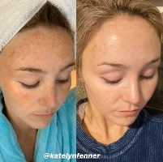
Post #10:
Here is another one of my favorite products! Deep Line Wrinkle Filler!
DEEP. WRINKLE. FILLER.
I am obsessed!
It is basically Botox in a pen!!! The retinol plumps up the wrinkle to fill it in instantly right before your eyes but also helps fill them in permanently over time as well!!!
It’s a targeted wrinkle product so you just put this specifically where you need it, not your whole face. This is very beneficial even to young women who may just have one forehead wrinkle.
- Who needs this?!?
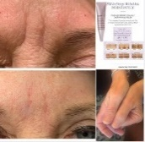
Post #11:
Here is a little about our TimeWise Repair® Volu-Firm® Set (sample in your Pampering Package)! I’m so excited for you to try it out this Thursday night 8pm!
It is a scientifically advanced regimen that targets:
Deep lines and wrinkles
Loss of firmness
Skin crepiness
Age spots
Uneven skin tone
Eye area puffiness
TimeWise Repair® Volu-Firm® Set
Backed by extensive work at the Mary Kay Research Center, TimeWise Repair® targets the multiple reasons why skin ages, instead of only addressing the outward signs. By maximizing your skin’s age-defying potential, TimeWise Repair® proves it’s never too late to rescue skin from the damage of the past and recapture a vision of youthfulness.
Suitable for sensitive skin
Fragrance-free
Non-comedogenic
Dermatologist-tested
Key Ingredients
The Power of the Volu-Firm® Complex
The patented Volu-Firm® Complex is the heart of the TimeWise Repair® regimen. The patented complex helps this innovative system of scientifically advanced products fight the factors that lead to the advanced signs of aging. The complex is a perfect union of three ingredients so vital to skin renewal that it is in every product.
A biomimetic peptide helps support skin’s natural processes* to help improve the appearance of sagging and wrinkles.
A skin volume-supporting peptide helps maintain natural hyaluronic acid,* a vital component of skin that plays a role in helping maintain youthful-looking volume and lift.
Plant stem cells derived from gotu kola to help support the natural framework of the skin.*
*Based on in vitro testing of key ingredients
Key Benefits
TimeWise Repair® Volu-Firm® regimen targets these advanced visible signs of aging:
Deep lines and wrinkles, including the eye area
Loss of firmness and sagging skin
Loss of skin volume
Loss of firmness and lift along the jawline
Skin crepiness
Eye area puffiness and dark circles
Wrinkles and crepiness in the neck area
Age spots and uneven skin tone
Thinning, more fragile skin
Uncomfortable dryness
Claims and Benefits
The regimen is clinically shown† to deliver these age-defying results:*
Reduced look of deep lines and wrinkles, and improved look of wrinkle severity
Lifted appearance is restored
Improved skin firmness
Improved skin elasticity
Enhanced appearance of skin clarity
Improved overall appearance
Joyful MK Beauty
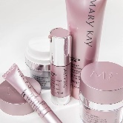
Post #12:
Which would you choose? Fragrance-Free or White Tea & Citrus?
This three-step, spa-like treatment revitalizes and rejuvenates the look of hands, so they feel renewed and instantly look healthier.
Instantly, hands feel moisturized, soft and smooth.
•Satin Hands® Satin Smoothie®
•Refining Shea Scrub
•Satin Hands® Nourishing Shea Cream pamper hands with shea butter.

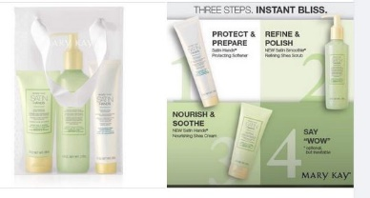

Post #13:
HOT TIPS: Tech (Neck) Support is Here!
Mary Kay skincare can help lift and tighten skin, fill deep wrinkles and more!
Did you know
Staring down at your smartphone could be aging the skin on your neck and causing lines and wrinkles? But never fear – your tech-neck support is here!
Tips
Use proper posture. Instead of holding your phone at chest or waist level, hold it closer to eye level. Or make it a habit to look down with your eyes, keeping your chin level instead of bending your neck.
Slash screen time. Set reminders to prompt you to take breaks from your phone throughout the day, especially on weekends!
Lift and Tighten
This serum helps the neck appear firmer and more lifted. It also softens the look of lines and wrinkles on the neck and improves the look of crepiness in the neck area.
TimeWise Repair® Volu-Firm® Advanced Lifting Serum
Fill Deep Wrinkles
After using this effective product, 100 percent of women showed an improvement in the appearance of wrinkle severity.† The targeted formula immediately fills in deep wrinkles and helps improve their appearance over time.
TimeWise Repair® Volu-Fill® Deep Wrinkle Filler
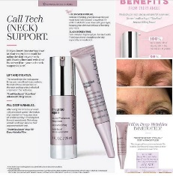
Post #14:
Jen's Favorite Product - Botox in a Bottle!
Also, known as our TW Repair Revealing Radiance Facial Peel! Every girl needs this in her life!!!!
The glycolic acid in Revealing Radiance® Facial Peel goes to work immediately, removing dead skin cells from the skin’s top surface layer.
But, did you know, it is also working on the layers beneath your skin to make it smoother?
**Skin’s radiance is revealed
**Skin smoothness is significantly improved
**Fine lines and wrinkles look reduced
**Skin looks rejuvenated and revitalized with a more even tone.
That’s because the glycolic acid is paired with an exclusive blend of calming botanical extracts, including a marine extract that has been shown to help provide essential hydration.
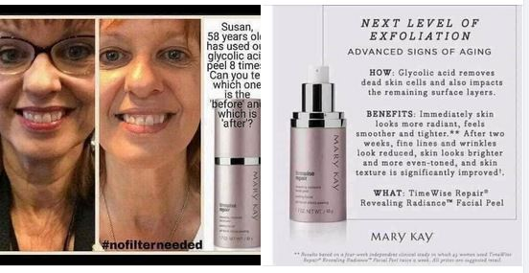

Post #15:
Moisture Renewal Gel Mask!
Get 10 skin-renewing benefits in 10 pampering minutes!
And lock in vital moisture to help your skin look fresher and more youthful.
Skin appears less stressed, feels nourished, purified and calm.
Instantly hydrates while also locking in moisture.
Helps reduce the appearance of pores as well as fine lines and wrinkles.
I sleep in this mask 1-2 nights a week. My skin truly loves the extra hydration since the MAJORITY of your facial skin repair occurs at night.
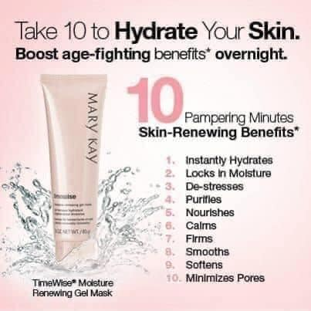
Post: Clinical Solutions
Got damage on your skin or sunspots?!
Special deal and more information on this amazing product tonight!
You’re going to want to read this...
𝟪 𝓌𝑒𝑒𝓀𝓈 𝓉𝑜 𝒶 𝓃𝑒𝓌 𝓎𝑜𝓊, introducing:
•ᴍᴀʀʏ ᴋᴀʏ ᴄʟɪɴɪᴄᴀʟ ꜱᴏʟᴜᴛɪᴏɴꜱ™ ʀᴇᴛɪɴᴏʟ 0.5 ꜱᴇᴛ•
We FINALLY HAVE RETINOL and we’ve been keeping it a juicy secret for SO LONG! Long enough that we’ve been trialing it and training on it so that we can share with you!
A new level of dermocosmetic performance to complement your nighttime skincare routine. The set includes Retinol 0.5 serum and Calm + Restore Facial Milk.
These products are designed to be used together as part of the eight-week retinization process developed by Mary Kay!
You’ll receive:
•Retinol 0.5 serum
•calming milk
•regimen tracking sheets
•me at your beck and call to answer and questions and help you through the process
Wondering how to shop?? You can place an order 1 of 3 ways:
1) Message me on Facebook messenger
2) Go straight to the website: www.marykay.com/JenSemelsberger (all discounts will be taken off before card is processed)
3) Good Ol' Fashion; call, text or email; 301-922-7038 mk@jenbesecker.net

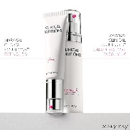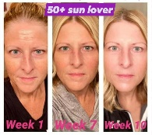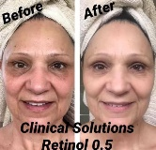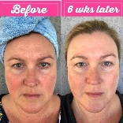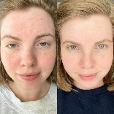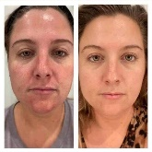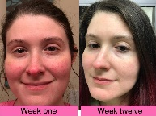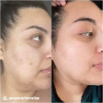

Post: Sonic Brush
THE BEST SECRET to ultra clean & healthier skin for you:
You can enjoy even more skin benefits from the Skinvigorate Sonic™ Skin Care System with multiple attachments:
Prep your skin for the next step in your skin care routine! Use Skinvigorate Sonic™ Facial Cleansing Brush Head for a deep clean that gently lifts away pore-clogging impurities.
Boost your serum by adding the benefits of facial massage! Use the Skinvigorate Sonic™ Facial Massage Head to create an invigorating facial experience in the comfort of your own home.
Simply snap on and snap off to transform your device in an instant!

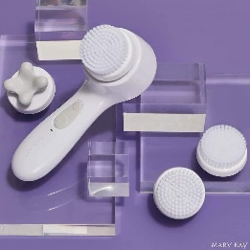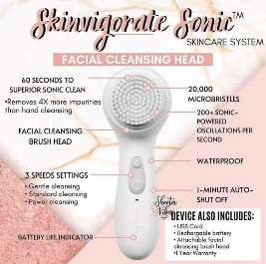

INTERACTIVE POSTS:
Love Post:
What do you love about Jane Doe our hostess with the mostess?
Comment below for 5 tickets into a prize drawing on the FB Live Party on 2/1 at 7pm!
Please make sure to PM me your address so I can send you a pampering package full of samples to try during the FB Live event.
(Tag Names)

Something Good Post:
Check-in daily for any post with a
These posts will get you entered into a prize drawing!
2021 has been interesting to say the very least! Tell me something GOOD that has happened!?
(Tag Names)

Post:
Let me know below for a ticket into the prize drawing!
(Tag Names)
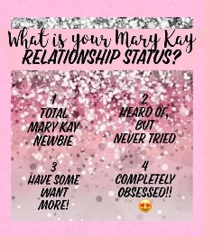
DAYS OF THE WEEK POSTS:
Monday:
Monday MVP
The Tone Correcting Serum! It took 10 years of development to harness the power of the Navy Bean, but so worth it! This patented formula not only brightens the appearance of your skin, but helps with hyperpigmentation, dark spots, and sun damage- leaving you with a noticeably more even skin tone with consistent use. Appropriate for every skin tone and type, this formula is super light and leaves you more confident in your skin- even without makeup!
Would you like to try it??
(3 pics below & change day of the week)

Tuesday:
It’s Taco Tuesday!
- Do you prefer Hard or Soft
(Tag Names)

Wednesday:
Wednesday Wisdom: One of My Favorite Things is our Undereye Corrector.
Many women make the mistake of putting regular concealer under their eyes. If you have ever tried this you may notice that it seems to just highlight the area rather than conceal the dark circles. For extreme dark circles, you can use the corrector and then put the concealer on top. (I have found that the Hydrogel Eye Patches and Undereye Corrector is a magic combo).
The dark circles are neutralized by a peach-toned corrector. Do this after your foundation and watch the circles disappear PLUS your eye area will look more lifted & you'll get a more youthful look.
Wondering how to shop?? You can place an order 1 of 3 ways:
1) Message me on Facebook messenger
2) Go straight to the website: www.marykay.com/JenSemelsberger (all discounts will be taken off before card is processed)
3) Good Ol' Fashion; call, text or email; 301-922-7038 mk@jenbesecker.net

Thursday:
It's Thursday Thankful, and today I am so thankful for my Indulge Soothing Eye Gel!
This little jar is jam packed full of antioxidants, soothing agents, and skin conditioners to help de-puff, tone, and firm your eye area. You can use this little jar throughout the day- and on top of your makeup!- to help keep puffiness at bay while you're looking more awake and bright! Tired, allergies, emotional movie? The Indulge Soothing Eye Gel has you covered!
Pro Tip: keep it in the fridge for added cooling benefits!
Post Friday or Saturday evening:
Happy Friday Do you prefer red wine or white wine?!?! Red for me!

PRIZE POSTS:
PUCKER UP!
**PRIZE ENTRY!** for 2 ENTRIES!
Comment below with a pic of your lip print and your pucker personality! This is SO much fun!!!
Steps:
Apply your favorite shade of lipstick or gloss
Kiss a piece of paper
Compare your lip print with the ones shown here!
- See what the Kissologist reveals about you!

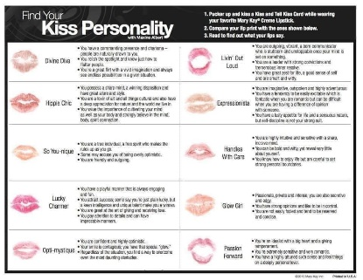

FALL TIME POSTS
Fall – Lip gloss: Post
GO NUDE this season!
Fall is just around the corner and so is cooler weather (unless you live in the Sunshine State). I don’t know about you, but autumn makes me in the mood for pumpkin spice lattes, cute boots and knit sweaters! When the leaves change colors and begin to fall it’s time to hang the autumn wreaths and decorate with pumpkins. It’s also time to change up your skincare and glamour routine.
- Look at this beautiful lipgloss shade...Tawny Nude!

(FALL) Party Day Post: (Morning of Party Day)
Happy Fall
- Game time!!! Winner to be picked once we make it through the alphabet. If we get to Z, start over with A. Every comment will get you an entry on the random wheel!
(Link party name)

Candy Post:
What are your favorites? I love Snickers & Almond Joy

Halloween Post:
PARENTS: Do you spend Halloween night or the following morning scrubbing your kids' face until they cry?? For easy makeup removal.... Grab some MK Oil-Free Eye Makeup Remover! Yes, it IS for the eyes BUT, if it's gentle enough for the eyes, the whole face (and body) can use it as well!
Halloween makeup can stain the skin and can be really hard to remove from the skin without a little pain.
SO...... Do yourself a favor! Use a little PRIMER under ANY and ALL Halloween makeup this year!
The Primer will help create a layer of protection on the skin so the makeup is easy to remove without painful scrubbing!
For EXTREME cases: If makeup is not lifting off skin easily, apply Intense Moisturizing Cream to the area, allow a warm wet cloth to sit over top and gently wipe off! Reds can be a PAIN to remove!
Have a happy and safe Halloween everyone!

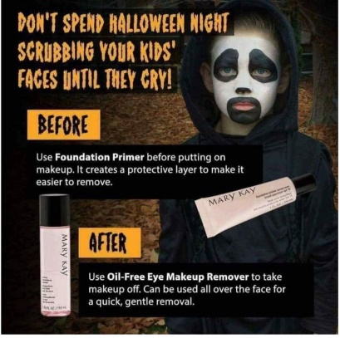

Interactive: Thanksgiving Posts
If you could only pick one, what would it be?!?! Pecan for me! !!!

WINTER TIME POSTS
Satin Lips (Winter)
Exfoliation is a MUST, especially in the winter! Satin Lips! Special deal on Satunf Lips announced tonight during the party!!!
Who has dry lips this winter?
We exfoliate our face and body, we can't forget about our lips
The Satin lips set is a product for everyone-- women, men, even kids!
Put on the shea sugar scrub for 1-2 minutes, wash it off and apply the shea butter balm for a moisturized smooth feel!
The scrub can be used as needed, and the balm can be used everyday! I love that it shows the true color of your lips and can be applied over a lipstick for more moisture!
Wondering how to shop?? You can place an order 1 of 3 ways:
1) Message me on Facebook messenger
2) Go straight to the website: www.marykay.com/JenSemelsberger (all discounts will be taken off before card is processed)
3) Good Ol' Fashion; call, text or email; 301-922-7038 mk@jenbesecker.net

Winter or Holiday Game Post (Morning of Party Day):

It's Wintertime!
Game time!!! Winner to be picked once we make it through the alphabet. If we get to Z, start over with A. Every comment will get you an entry on the random wheel!

Lips (Valentines)
Valentine's Day is coming!! Get those lips ready or surprise your loved ones with some of Mary Kay's lip smacking gifts

