Glamour Post:
What color our your eyes?!?! Comment below for a ticket
Do you ever wonder..... "What colors really bring out my eyes?" or "How do I wear a Bold or Bright Shadow without taking away from the color of my eyes?"
𝐁𝐫𝐨𝐰𝐧, 𝐆𝐫𝐞𝐞𝐧, 𝐇𝐚𝐳𝐞𝐥 𝐨𝐫 𝐁𝐥𝐮𝐞..... 𝐓𝐡𝐞𝐫𝐞'𝐬 𝐚𝐥𝐰𝐚𝐲𝐬 𝐚 𝐅𝐔𝐍 𝐂𝐨𝐥𝐨𝐫 𝐟𝐨𝐫 𝐲𝐨𝐮!⁣
First we'll start with the Basics.....What colors can you coordinate in your eye shadows to get the MOST from your natural eye color?
𝐁𝐥𝐮𝐞 𝐄𝐲𝐞𝐬: Peach toned eye shadows bring out ANY blue eyes! When looking at neutral shadows, go with warmer tones to really set your blue off!
If the eye color is more icy blue, stick with cool tones such as purples, soft pinks, pastel tones. If the eye color is more of a deeper blue, royal blue or navy blue, then try a color like Shiny Penny.
𝐆𝐫𝐞𝐞𝐧 𝐄𝐲𝐞𝐬: Purples have always been the dominate shadow tones for green eyes. When looking at neutrals, go with a plums or grey browns. Cool neutrals!
Green eyes LOVE PINK and red tones like Burnished Bronze. These tones really set fire to green eyes! Vibrant pinks should be worn with a lighter green eye. Deeper burgundy and reds look so dramatic with a deep green eye. The NEW Pink & Purple Foil Eye Shadow Duo will look absolutely stunning on green eyes!
𝐁𝐫𝐨𝐰𝐧 𝐄𝐲𝐞𝐬: The interchangeable eye! Meaning, the eye color that can wear anything without diluting the color of the eye!
Brown eyes LOVE BLUES!! Light blues, dark blues, shimmer blues!! Browns have a tad bit of a warm tone in them so Blue Shadows really pull them out!! Try Midnight Star or Evening Navy
𝐆𝐫𝐞𝐲 𝐄𝐲𝐞𝐬: follow the rules for Blue eyes
𝐇𝐚𝐳𝐞𝐥 𝐄𝐲𝐞𝐬: find the dominate color in the hazel and follow above! (golden hazel, use bright bold purples such as Frozen Iris or Sweet Plum).
Have fun experimenting with some new shades and show off those beautiful eyes!

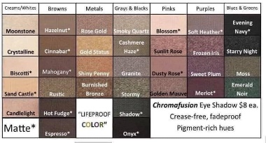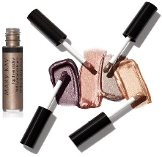

Glamour Post:
What’s your eye shape?!?
Comment below for a ticket
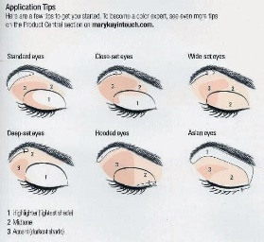
Glamour Post:
Here’s a step-by-step guide on how to lock in lasting lip color!
STEP 1: Start with TimeWise Age-Fighting Lip Primer on clean, exfoliated lips.
STEP 2: Line your lips for definition and long-wearing color that doesn’t bleed.
STEP 3: Give your lips a swipe of lipstick.
STEP 4: Top off your look with Mary Kay Unlimited Lip Gloss.
Vanessa is wearing Mary Kay Lip Liner in Medium Nude, Mary Kay Gel Semi-Matte Lipstick in Nude Blush and Mary Kay Unlimited Lip Gloss in Sheer Illusion.

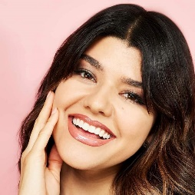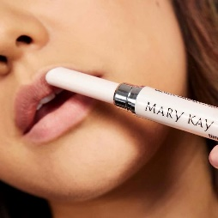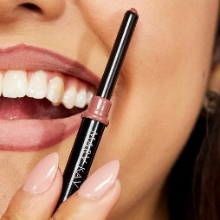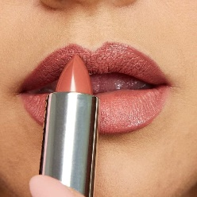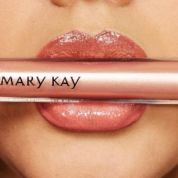

Glamour Post:
𝐓𝐡𝐞 𝐅𝐢𝐧𝐢𝐬𝐡𝐢𝐧𝐠 𝐒𝐩𝐫𝐚𝐲....I don't think I will 𝐄𝐕𝐄𝐑 get tired of talking about this amazing product!!

It is 𝐓𝐎𝐓𝐀𝐋𝐋𝐘 for ALL skin types. It does 𝐍𝐎𝐓 dry the face or leave an oily substance on the surface. For extra-long wear, and to keep sweat at bay, apply all your skin care and primers. Then, mist your face and allow to dry before applying your makeup.

After 𝐀𝐋𝐋 makeup is done (before mascara), spray the face again again to seal the deal!!

Now apply mascara.... but 𝐍𝐎 𝐒𝐐𝐔𝐈𝐍𝐓𝐈𝐍𝐆!! Squinting causes lines at the end of the day! Have a relaxed face while misting.

Ever get embarrassing sweat lines under your armpits, stomach lines, even your back? Spray yourself before putting clothes on in your "sweat spots" (before deodorant). You will be 𝐒𝐎 impressed at how well the Finishing Spray Keeps ALL sweat at bay!

Ever meet or see the woman with "powder face"? You could blow on her and a HUGE puff of powder dusts from her face?? Show this woman the Finishing Spray! It removes the over-powdered look and sets the makeup at the same time, giving the elasticity of the face 𝐁𝐀𝐂𝐊 after powdering! This leaves you with a beautifully made-up face that looks youthful and fresh!!!
It's kinda like 𝘍𝘳𝘢𝘯𝘬'𝘴 𝘙𝘦𝘥 𝘏𝘰𝘵 - Put it on everything!
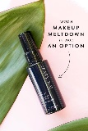
Glamour Post:
Who else loves this look ?!?!
Burnished Bronze
Shiny Penny
Candlelight
Biscotti
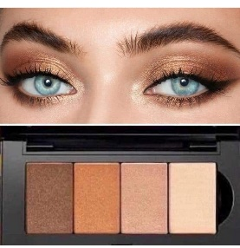
Glamour Post:
Brows frame our face! Look at Katie’s brows that WOW! This doesnt even have liner either!!

Pro tip! The Mary Kay® Volumizing Brow Tint can give thin, sparse or over-tweezed brows a visible boost!

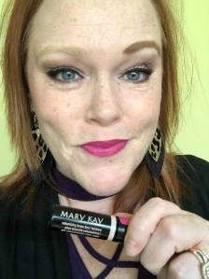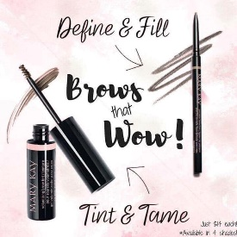

Glamour Post:
Who needs help with brows?
Brows are so important check out my girlfriend, Nicole Jones, before and after brows!
Our brow definer pencil is long-wearing and waterproof, to support your look all day. The precision brow liner comes in 5 different shades and has a thin, roll up liner that you can stroke on to look like hair, filling in your brows.
The Volumizing Brow Tint comes in 4 shades to shape, set, and tint your existing brows- to keep them in place and darken them a little (brow tinting is very IN right now).
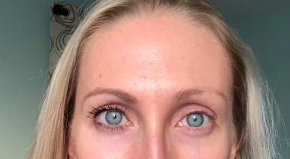

Glamour Post:
Check out my girlfriend trying all the new color Hydrating Lipsticks! They are all beautiful!
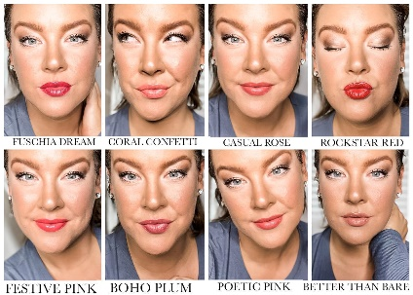

Glamour Post:
Here are some beautiful glamour looks and how to apply them!
Comment with your favorite look for a ticket
Pinks & Mauves
https://bcove.video/2ya7g4k
Warm Metals
https://bcove.video/2PsHLBS
Golden Moss
https://bcove.video/2Pv4IVf
Berries & Gold
https://bcove.video/2CCW2JF
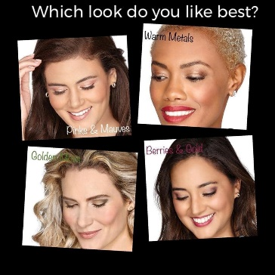

Glamour Post:
Contouring Tips!
Contour with the bottom short bristles
Blush in the center of the brush
Highlight with the top longer bristles
Plus... the "DIMPLE" for your thumb for proper application!
A MUST HAVE Brush! This 3-in-one brush is included in our Brush Collection or you can purchase it by itself too!
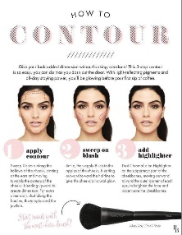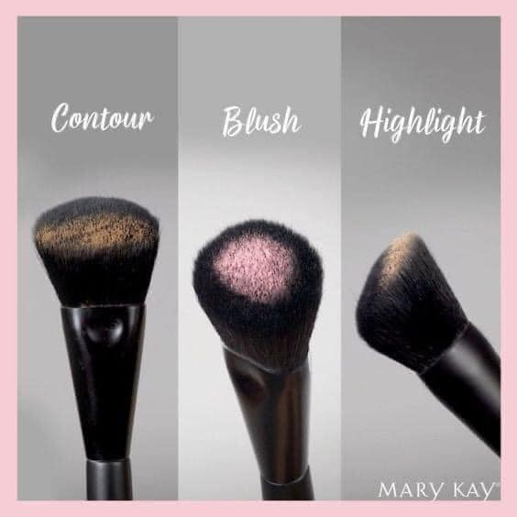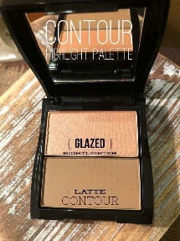

Glamour Post:
Beauty Resolutions
Raise your right hand and promise me that you will NEVER sleep with your makeup on and that you will replace your makeup as suggested!
- Comment below so I know you promise and for another entry!
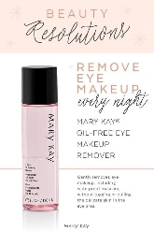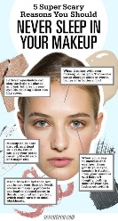

Glamour Post:
How many lipsticks and lip glosses do you have in your makeup bag or purse ? Comment below for additional tickets
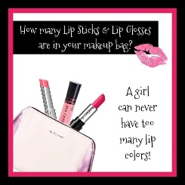

Glamour Post:
- NEW SPRING ITEM Supreme hydrating lipstick in 8 great colors! What color is you favorite? Let me know in the comments below and someone will WIN one FREE (winner to be picked later this week)

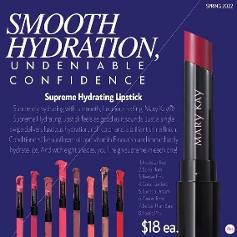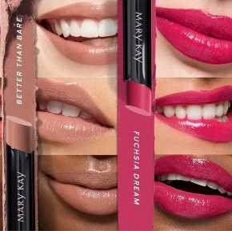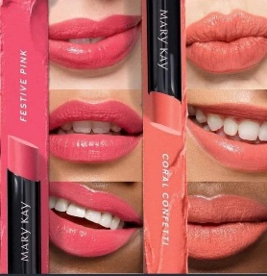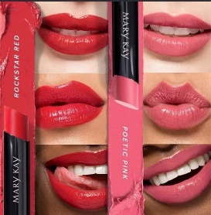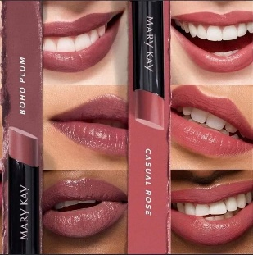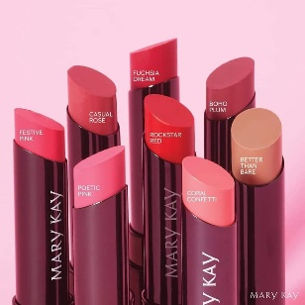

Glamour Post:
- Lip Liner 101
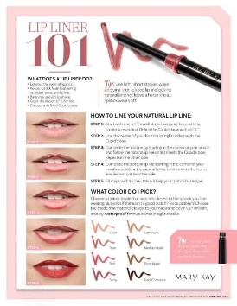

Glamour Post:
Who El-sa needs some mascara in their life? Try our new "Lash Love Fanorama" Mascara! (It's my favorite.)
Look how all of our Disney friends love their Mary Kay too.

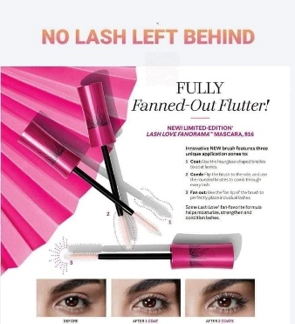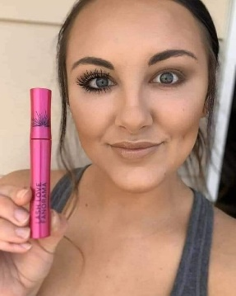

Glamour Post:
𝐓𝐈𝐏: 𝐀𝐋𝐋 𝐀𝐁𝐎𝐔𝐓 𝐒𝐇𝐈𝐌𝐌𝐄𝐑!

Shimmer must be worn in the right areas to truly benefit from the product, just like any products/makeup. It's nothing to be afraid of! Each and everyone of us should have a mix of shimmer and matte colors on a daily basis to get the ultimate, most youthful glow!

First of all, do 𝐍𝐎𝐓 apply shimmer eye shadow to the 𝐁𝐀𝐂𝐊 of your hand to see “if it ages you.” Our hands & eyelids are totally different textures. If you did the same with a matte shadow, it would look very dry and cracky. Choose a skin spot that's tight and thin. Inner forearm works GREAT!

Shimmer is ageless - it can be bold or soft, glamorous or natural.

It draws attention to the cheeks and eyes, making the skin reflect light which gives off that beautiful shine.

How to go 𝐛𝐨𝐥𝐝.... (liquid eye shadows used as a base, then build powder shadows over top)

How to be 𝘴𝘰𝘧𝘵 ... Use skin tone colors for a soft fresh color wash.

Here's how to make ANY and ALL Mary Kay Shimmers Ageless:

-NO high shimmers in the crease of the eye. This keeps the shadow from going into unwanted areas. Use a matte shadow in the crease!

-Keep the shimmer on the brow bone and on the lid, but be careful with high shimmer on the brow bone, as it can sometimes give a hooded effect.

- No shimmer under the eyes.

Here are places shimmer 𝐃𝐎𝐄𝐒 belong for ALL Ages!

- All over the lid
- Dusted on the brow bone
- Apples of cheeks & cheekbones for a healthy glowing effect
-Tear duct of the eye
-C shape of the eye!

We 𝐀𝐋𝐋 need a balance! A little bit of matte and a little bit of shimmer!

𝐅𝐨𝐫 𝐦𝐨𝐫𝐞 𝐘𝐨𝐮𝐭𝐡𝐟𝐮𝐥 𝐒𝐤𝐢𝐧: Shimmer can give a soft, fresh or natural glow to the skin. It can also be used to bump up your glamor look.

𝐅𝐨𝐫 𝐌𝐨𝐫𝐞 𝐌𝐚𝐭𝐮𝐫𝐞 𝐒𝐤𝐢𝐧: Shimmer gives the appearance of fresh, hydrated skin with a healthy, elastic look. It brings attention to the eyes and revives the energetic, awake look to the face, giving a luminous appearance to the skin (what's used on celebrities at red carpet events to give that satin-soft glow).
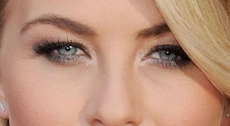

Post:
The secret to a flawless face is using Foundation Primer. It glides on effortlessly and dries quickly to create the perfect canvas.
You know how you prime walls before you paint?
You apply Foundation Primer for the exact same reasons. In fact, here’s what women had to say in a two-week independent study:
98% said it applies smoothly and evenly
90% said it helped skin look smoother
87% said it helped perfect the appearance of skin
85% said it helped reduce the appearance of pores
85% said it extended the wear of makeup
81% said skin looks healthier and helps skin look firmer
You can even wear it alone!
When worn alone it:
• Evens out skin texture
• Reduces the appearance of pores, fine lines and wrinkles, and other skin imperfections
• Improves skin’s complexion
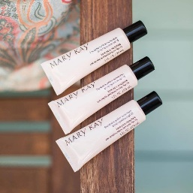

Post:
- lip tips plus a bonus one primer helps feathering and has anti-aging built in liner keeps it all in place and helps define and create your shape without the crazy fillers or injections our gel formula is like a cushion hugging your lips with high pigmented colors and add our translucent powder over any lipstick to make it a matte and seal the deal find your perfect shade today
.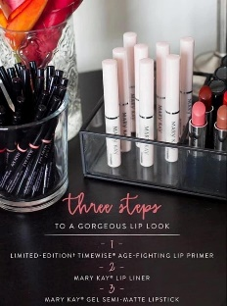
Post:
One of My Favorite Things is our Undereye Corrector.
Many women make the mistake of putting regular concealer under their eyes. If you have ever tried this you may notice that it seems to just highlight the area rather than conceal the dark circles. For extreme dark circles, you can use the corrector and then put the concealer on top. (I have found that the Hydrogel Eye Patches and Undereye Corrector is a magic combo).
The dark circles are neutralized by a peach-toned corrector. Do this before and/or after your foundation and watch the circles disappear PLUS your eye area will look more lifted & you'll get a more youthful look.

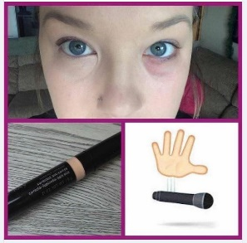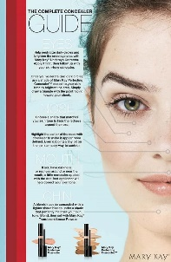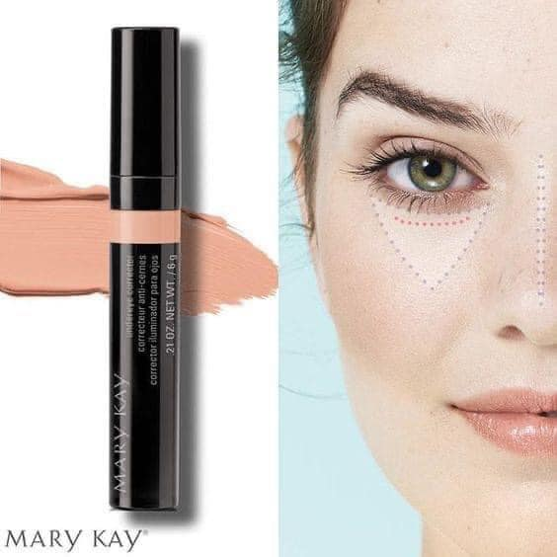

Post:
Going away for the weekend? This is the perfect get-away bag for all your favorite skin care and cosmetics!
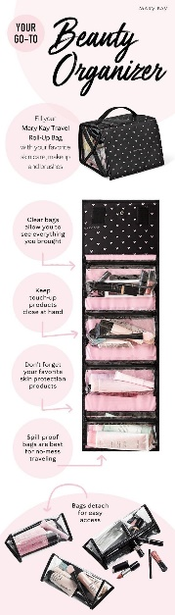
Post:
What would you love to learn more about?!?! Comment below for a ticket into the drawing!
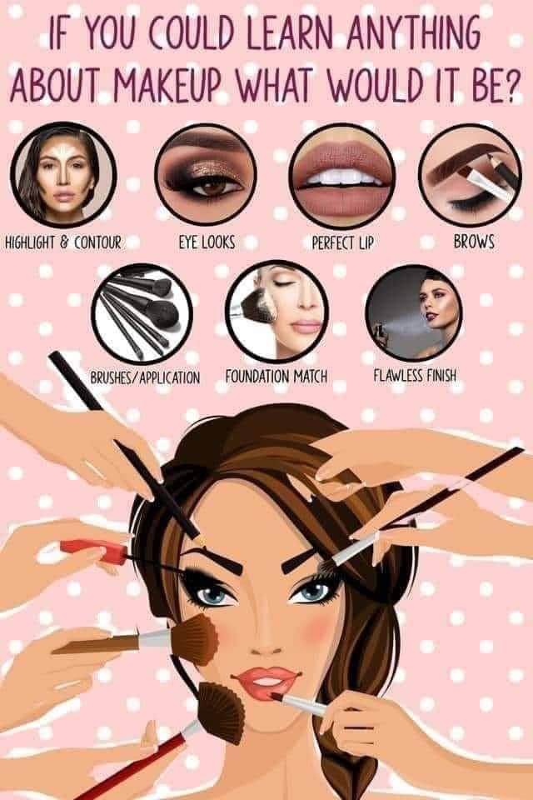

Post:
Love YOUR Lashes!
Comment below for a prize drawing entry.
Many of you ask which mascara do I wear...LASH INTENSITY!
Watch this fun video explaining how to use it. http://vid.us/fcgpe7
What do you look for when picking a mascara?...
-volume
-lengthening
-defining
-waterproof
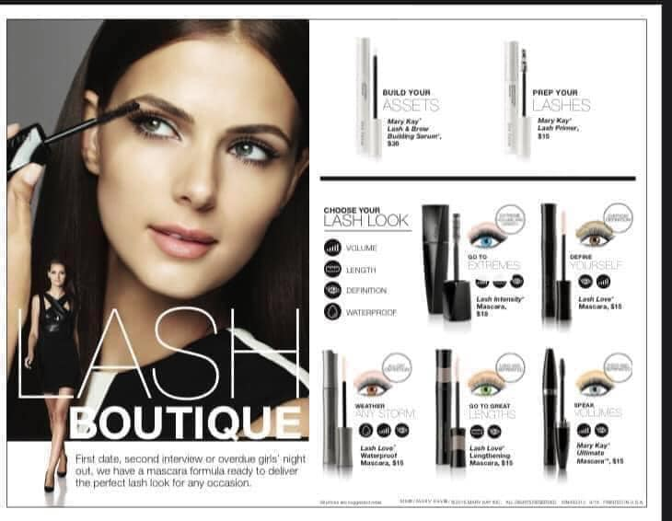

Post:
Comment your favorite color of lipgloss below you would love to try and get for FREE!!!!!
(Tag Names) add selfies after numbered lipglosses.
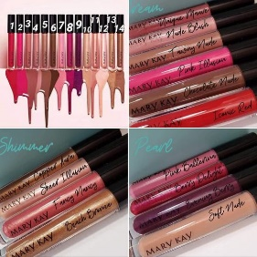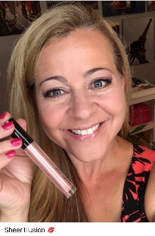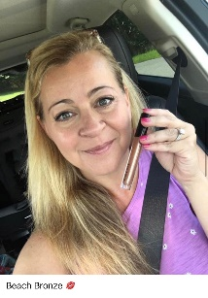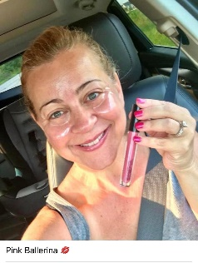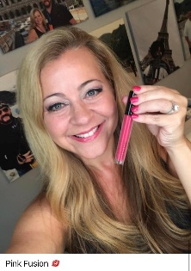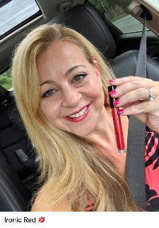

Post:
Liquid eye shadows... ummmm yaaassss please! Available in 4 colors! Mix & Match Goes on super easy and smooth! Wondering how to shop?? You can place an order 1 of 3 ways: 1) Message me on Facebook messenger 2) Go straight to the website: www.marykay.com/JenSemelsberger (all discounts will be taken off before card is processed) 3) Good Ol' Fashion; call, text or email; 301-922-7038 mk@jenbesecker.net
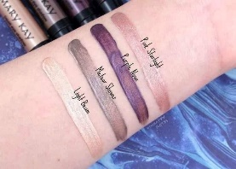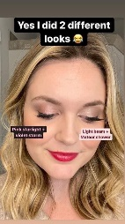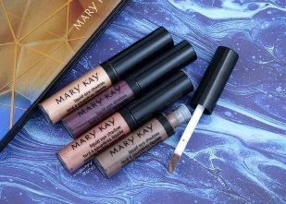

Post:
Going out tonight? Seeing your friends maybe a special occasion and that's a perfect time for you to look your best. Who likes to do their hair and makeup?
If you had a girls night.... tell me what your favorite plans to do together are!
Comment below for additional tickets

Wednesday:
It's Why Wednesday!
Why should I highlight and contour? How do I do that??? Video below
You don't HAVE to highlight and contour, but it is a fun way to step your makeup game up a notch to add depth to your look!
The purpose of contouring is to push back the areas of your face that you don't want to be as noticeable, and a highlighter brings out those areas of your face that you'd like to spotlight!
Basically, you're going to add a little shadow to make certain areas seem to recede, so adding contour underneath your cheekbones, in the hollows of your cheeks, appears to make your cheekbones higher, and your face thinner. Adding contour to your hairline can make a pronounced forehead appear smaller. Just remember light layers and blend, blend, blend!
Highlighter has light-reflecting pigments to brighten! You can apply highlighter to the very top of your cheekbones to highlight your eyes, and along the ridge of your nose to help it appear straighter!
Highlight and contour can be used a number of ways and it's so fun! What are YOUR best contouring tips??
Here's a quick video to demonstrate contouring with Mary Kay Chromofusion colors!
http://marykay.gallery.video?videoId=5706254458001
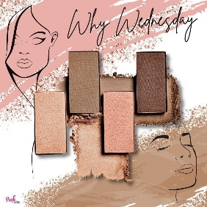

Wednesday:
Why Wednesday - Why are there so many types of foundation? What are they all for???
Answer: You can build your foundation wardrobe to suit your needs in different situations!
The TimeWise 3D foundations are full coverage, long wearing, oil controlling, skin-nourishing, and available in the widest range of shades.
The CC Cream is multitasking, fast applying, skin protecting, red-reducing, and super blending in just 5 shades.
The Mineral Powder is natural looking, light feeling, and wrinkle reducing.
The Crème-to-Powder has never moving, heat and humidity resistant, long wearing power.
The Sheer Mineral Pressed Powder is super light coverage, oil absorbing, face perfecting flawlessness.
So whether you're out on date night, running Saturday errands, off to work or out in the heat, we've got the perfect foundation to match your skin tone, type and coverage preference!

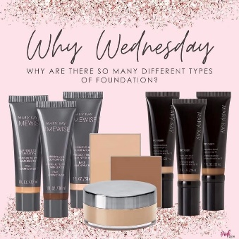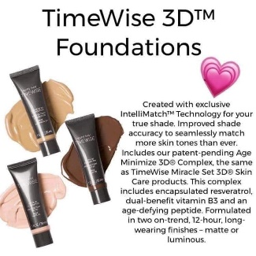

Friday-3:
TGIF!! Yay... Finally It's Friday & I'm feeling Fabulous!! What are your plans? I plan to have a Mary Kay Spa Night with some friends followed by dinner and movie night with the family!
