Post My Party – For Facebook Party with Individual Hostess

Start posts 7-10 days out from party. Start asking for addresses BEFORE that if possible.

POST 1 –
Hello ladies!!
My name is Abigail and I am Brianna’s friend & Mary Kay girl! I’m so excited to have you here!
I will be posting beauty tips and fun product scoop over the next few days!! AND our LIVE event will be SUNDAY, February 28th at 3:00pm cst! Make sure to put it on your calendar and carve out some “spa time” for YOU!
Our products are premiere line level... They are CRAZY GOOD!!
I look forward to sharing my love of this company and its products with you. If you are new to Mary Kay, please feel free ask me any questions you may have.
The fun actually starts this week! I’ll be dropping some fun posts which will help you get acclimated and also give you chances to be entered into a drawing to win FREE PRIZES – given away at the LIVE event!! I will be giving away some GREAT PRIZES!!
Anytime you see **PRIZE ENTRY** comment on that post and you’ll get entries for the drawings!

ADD a PIC of YOURSELF TO THIS POST!!

POST 2-
*ALERT! – Major FREEBIES in store for YOU!*
Before we get to our fun prize entry posts – I want to make sure you ALL got your FIRST FREEBIE!! If you haven’t already, please send me your address so that I can make sure you get your FREE sampler pampering pack out to you!!

POST 3 –
**PRIZE ENTRY**
Let’s START this party by spreading some LOVE!
Tell me how you know our fabulous hostess, Brianna!
Brianna and I used to teach together at Central High School together. She’s still an absolutely amazing teacher there!
POST 4 –
Let’s get the evening going with our first product post!!
A fan fav & TOP SELLER!! AND it comes in your sampler pampering pack! Do you have yours yet?!

Comment YES if you would love to detox your skin and have SMALLER PORES!
One of my favorite mk treatment products! AND..as you can tell it works!
Clear proof Charcoal Mask. For all skin tones & types. Male & Female too.
Can’t wait to try this together at our LIVE event on 2/28!
$24 for 30 treatments..only .80 cents a treatment
Triple-action charcoal mask acts like a magnet to deep-clean pores.
BENEFITS AT-A-GLANCE
*Activated charcoal acts like a magnet to unclog pores.
*Formula is clinically shown to instantly absorb excess oil and reduce shine.
79% of men and women agreed: “Skin looks clearer” after use.†
*Extracts of rosemary and peppermint deliver a fresh scent to awaken your senses.
*Revel in the gentle cooling sensation as you smooth the formula across your skin.
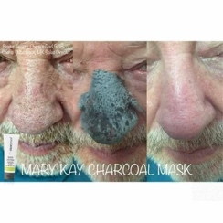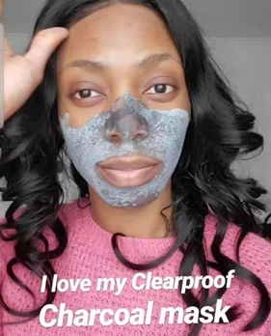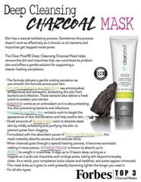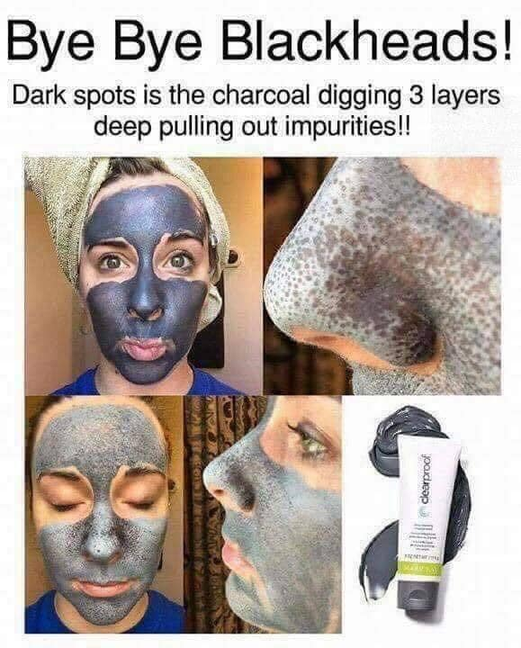

POST 5 –
**PRIZE ENTRY**
HOLY “GLOSS-A-MOLE”! LOL… seriously though, Mary Kay Corp just revamped our gloss formula into what has become my personal obsession. They are NOT sticky (my pet peeve – anyone else?), and they apply like a dream.
If you were to get one for FREE, which color would YOU choose?!

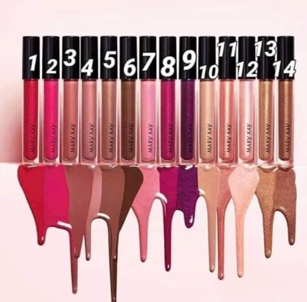

POST 6 –
**PRIZE ENTRY**
Anyone else have dark circles or undereye bags? Lmk if you’ve ever struggled with this issue before! No one should have to suffer ;)
I like to call this product a “nap in a bottle”😍
Our under eye corrector is incredible!
✨the peach tones cancel out blacks, blues, and purples
✨suitable for sensitive skin around the eyes
✨suitable for contact wearers

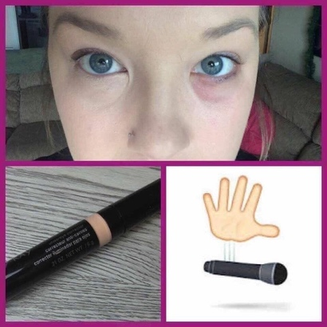

POST 7 –
👉Pack Your Bags ladies! Pack.👏🏻Your👏🏻Bags 🧳

Undereye Bags that is!

Mary Kay is launching Hydrogel Eye Patches & “Eye” (see what I did there 😂) am totally amazed.

Here’s how they work:
Step 1: Put them under your eyes 👀
Step 2: Wait 20 minutes 🕒
Step 3: Remove them and lose your mind 🧠 at how good you look

Each Jar has 30 pairs - not 30 patches - 30 PAIRS!

❌ Goodbye fine lines & wrinkles
❌ Goodbye puffiness - everyone in TX needs that right now!
❌ Goodbye under-eye circles
❌ Goodbye Bags!

✔️ Hello lift
✔️ Hello moisture
✔️ Hello smooth
✔️ Hellooooo you
JAR OF 30 PAIRS of eye patches retails for $40
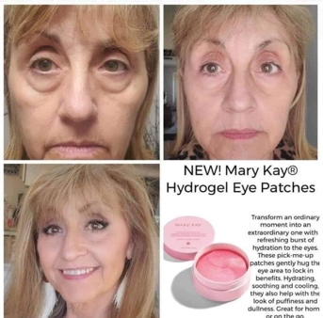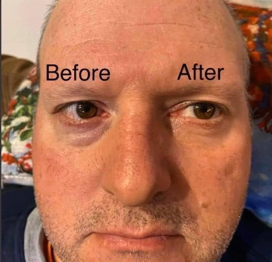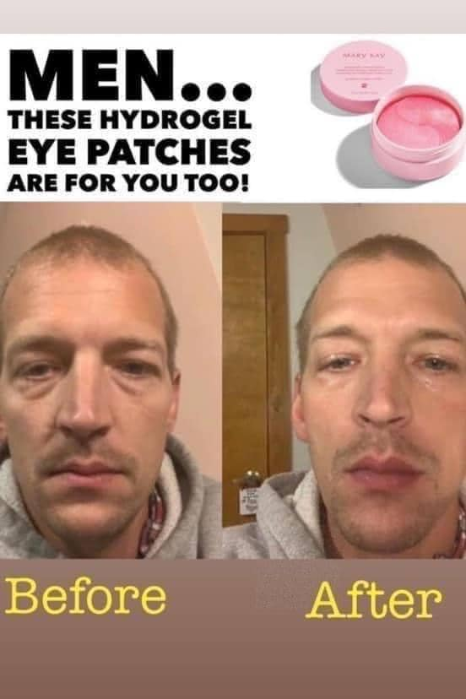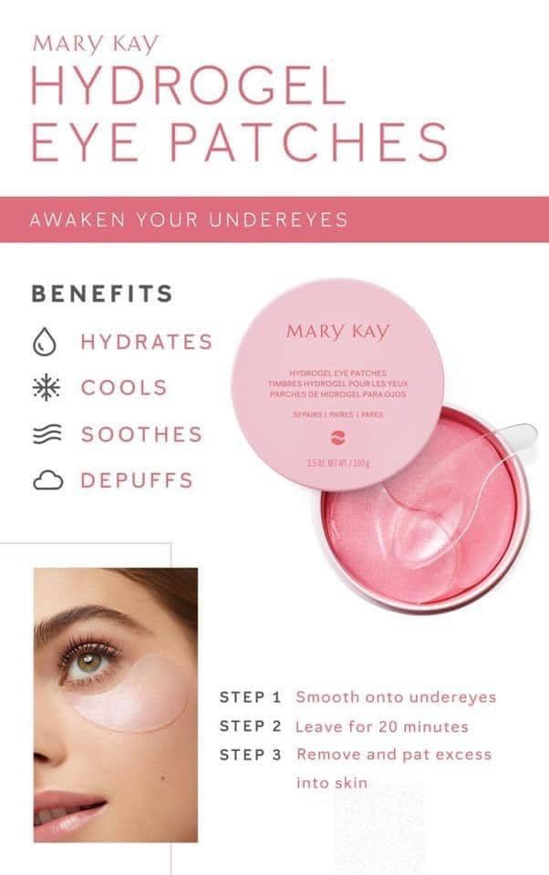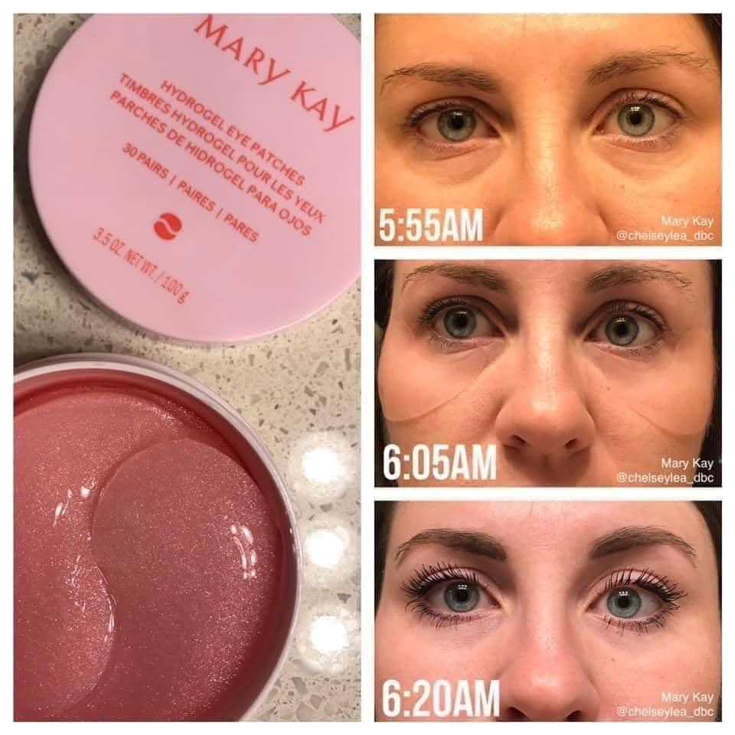

POST 8 –
**PRIZE ENTRY**
THIS OR THAT?!
Would you prefer a deep clean detox, “black-head-buster” charcoal mask?
OR
Some SUPER HYDRATION, “drink-of-water-for-your-skin” moisture renewing mask?
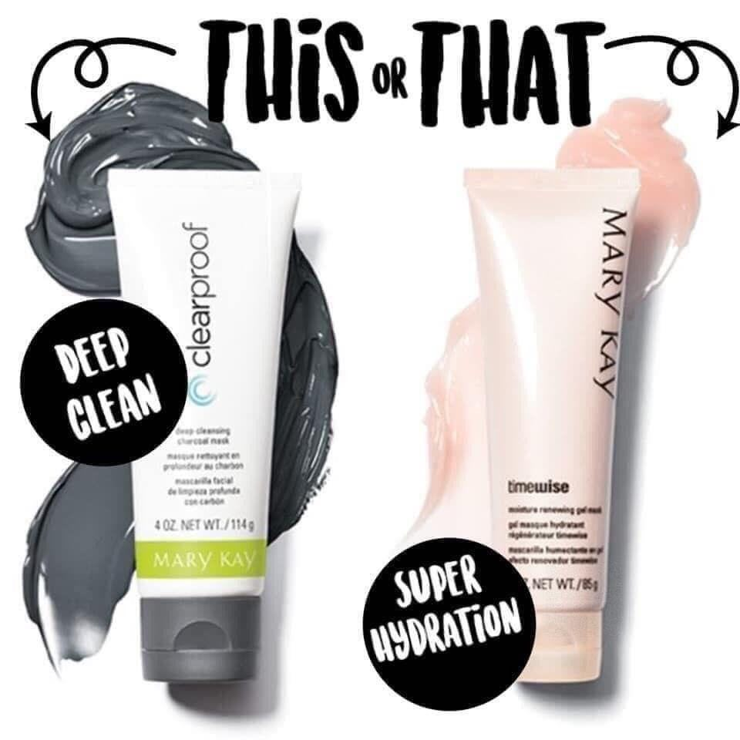

POST 9 –
Alright ladies! Time is working against us in the wrinkle, skintone and skin texture department!
BUT – we’ve got you covered!
This glycolic peel has become my BFF in recent years.
A Multi-layer exfoliant for skin texture that's SO smooth you can't stop touching it!!

🌟TimeWise Repair Revealing Radiance Facial Peel
Thanks to the power of glycolic acid, your skin’s own natural renewal process is enhanced as younger-looking, more radiant skin is revealed.
See clinically tested results in two weeks!*
Skin looks brighter.
The skin texture is significantly improved.
Fine lines and wrinkles look reduced.
The skin tone looks more even.

✅Check out the before/after picture of Susan who used it 8 times!

This is by far my FAVORITE Exfoliation treatment! 2x/week 15 mins a day!Mary Kay Facial Peel! The power of Glycolic Acid!!
$65

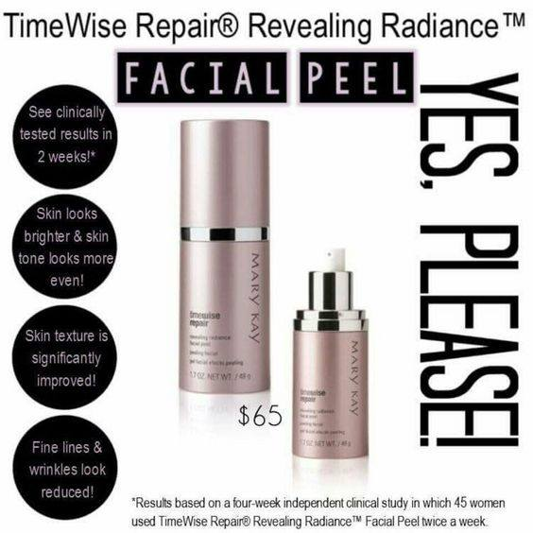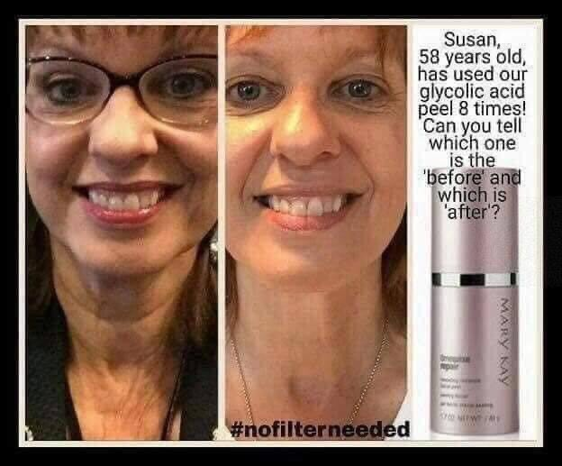

POST 10 –
**PRIZE ENTRY POST***
EVERY girl needs a good cleanser… but WHICH one is best for you?
A. Clearproof Cleanser – perfect if you are acne prone
B. Naturally Cleanser – derived from all natural ingredients
C. Botanicals – from our Teen line. A great cleanser to get your teen started on skincare! (and it smells like a Jolly Rancher candy!)
D. MK Men’s Cleanser
E. Volufirm Foaming Cleanser – our only cleanser that works to reverse aging
F. 4-in-1 Anti-Aging Cleanser – Cleanses, Tones, Exfoliated and Brightens ALL IN ONE STEP! It’s a MIRACLE (from our 3D TimeWise Miracle Set)

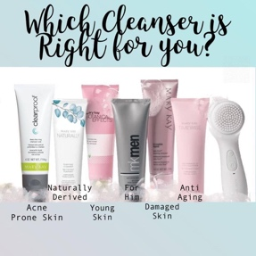

POST 11-
**PRIZE ENTRY**
Introducing: Mary Kay's TimeWise Miracle Set 3D set!!!!
DO YOU currently use this set?? Or will the LIVE beauty session be your first time to sample it??

It is EPIC if you want to “DEFEND (against free radicals - nasty stuff that breaks down our skin), DELAY aging and get DELIVERY of results” in less than 2 weeks!
BOTH: Normal/Dry and Combination/Oily Formulas available!
3 squirts twice a day FOR SUPER BUSY WOMEN who want RESULTS!!
TimeWise® Age Minimize 3D 4-in-1 Cleanser (removes dirt, makeup, surface oil)
TimeWise® Age Minimize 3DDay Cream SPF 30 Broad Spectrum Sunscreen** (defends against sun damage and hydrates for 12 hrs)
TimeWise® Age Minimize 3D® Night Cream (rejuvenates and tones while sleeping)
TimeWise® Age Minimize 3D® Eye Cream (hydrates the under where area like a charm)
Every product features our Age Minimize 3D Complex, including encapsulated resveratrol, vitamin B3 and an age-defying peptide.
Post below if you currently use it or want to know more
Click the link for more info http://vid.us/fqpdj

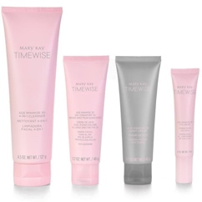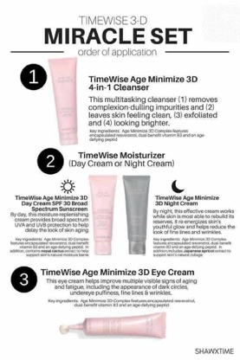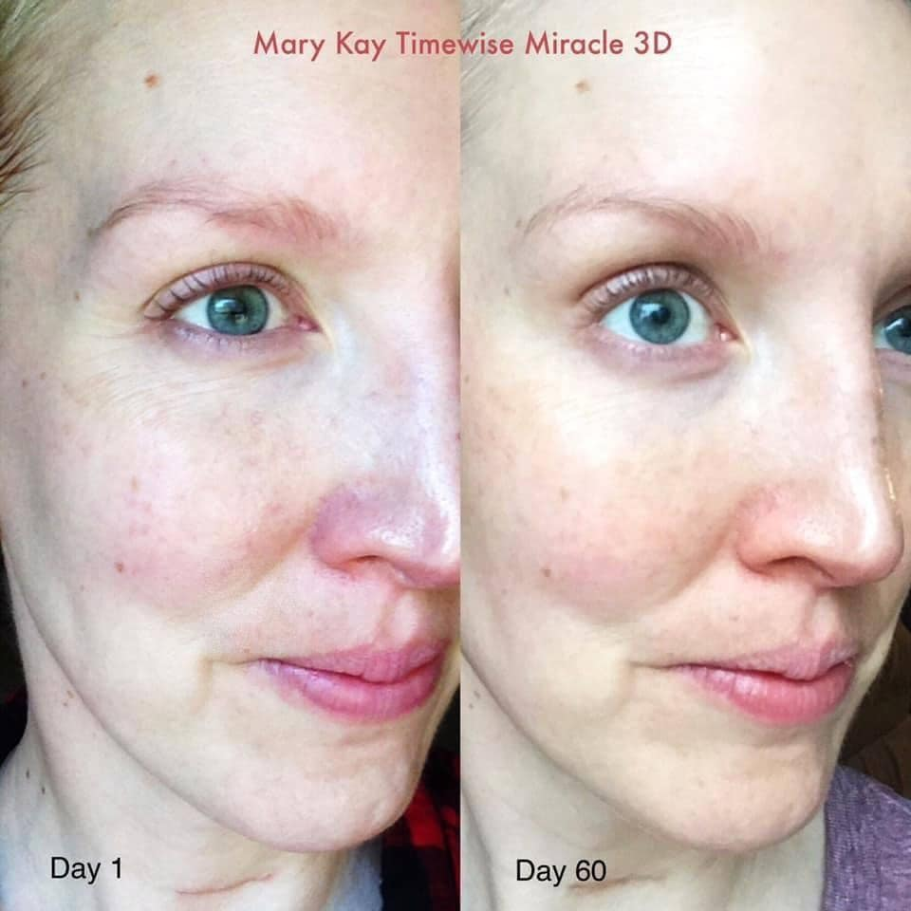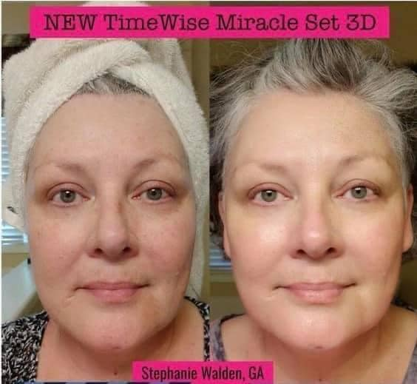

POST 12-
Did you know that MK skincare products have THE “Good Housekeeping” seal of approval?! PLUS, all of our skincare is FDA approved, and our Naturally line has the highest European certification – the ECOCERT from COSMOS!!!
Yes… we are fancy like that! Lol… we make it our priority to have safe and effective skincare for YOU!
Plus, we are cruelty-free and landfill free!

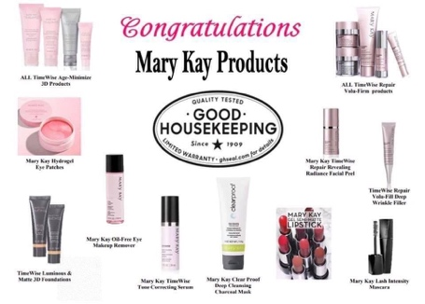

POST 13-
**PRIZE ENTRY**
How many candies are in the jar?! Closest guess gets 3 extra entries!

(I’m not sure how many are in this particular jar… but if you take a picture of one that you do on your own – you’ll know for sure and can use that pic!)

POST 14-
Have you ever wanted one of those “skincare spinny brush things”?! (I know, that’s a big technical term) I used to dream of having one and MK has delivered!!
I HAVE to show you one of my FAV products! 🧼 ✨

👉🏼👉🏾Introducing the Skinvigorate Sonic™ Skin Care System! It’s like a mini spa treatment in your bathroom!
Using the cleansing brush with your daily cleanser removes 4 times more dirt, oil, impurities, makeup and pollutants than hand-cleansing!!
•Rechargeable battery with USB cord means no searching for replacement batteries.
•Full charge allows for up to 30 days of usage (when used 4 minutes per day).
•Safely go from sink to shower, thanks to IPX7 waterproof standard.
💆🏽‍♀️When you add the Facial Massage Head to apply your serum there are even more benefits!!
Massage is known to promote microcirculation, bringing oxygen and nutrients to the skin. Women who used the Skinvigorate Sonic™ Facial Massage Head confirmed that fine lines appeared softened. Skin felt more resilient, and their faces felt revitalized. Daily use leaves skin looking healthier and feeling more fit. It also helps your serum absorb better into your skin!

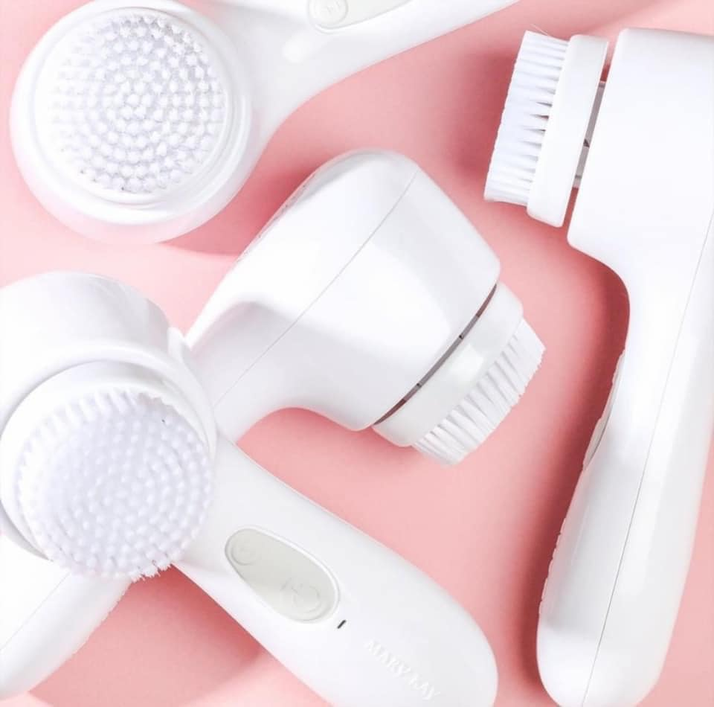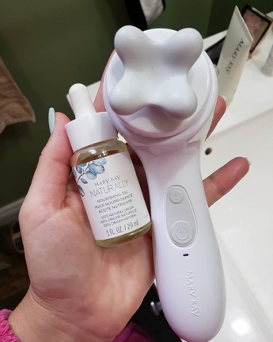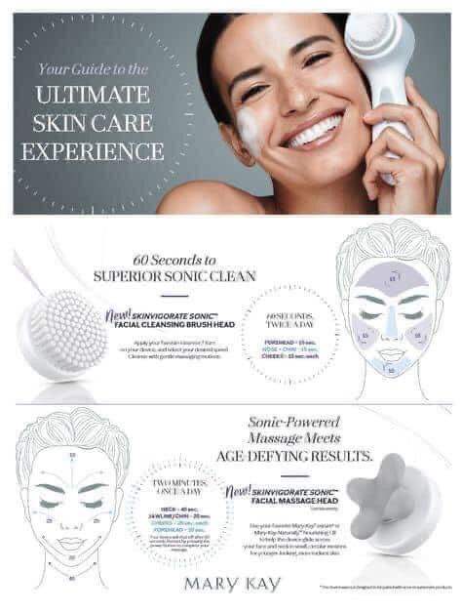

POST 15 –
**PRIZE ENTRY**
I posted earlier about our NEW, FABULOUS Hydrogel Eye patches! Even Jennifer Aniston had a pair of these on the other day!
And, here’s a PRO TIP for you: these can be applied to ANY problem area! Need better skin texture, softening of fine lines or wrinkles. Just apply as needed.
Where would YOU apply your set? Answer in the comments for an entry!

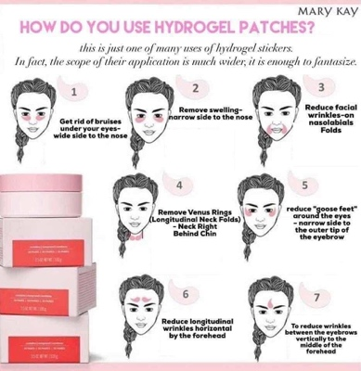

POST 16 –
**PRIZE ENTRY**
Where are my lip gloss girls at?! Even with the mask mandates, I still like to play with lip color!
How many lip sticks, lip glosses or even lip balms do you have in your makeup bag??
There’s no wrong answer – and a girl can never have TOO many!

POST 17-
**PRIZE ENTRY**
Any other busy ladies - moms, aunts, grandmas out there?! I KNOW you could all use some “ME” time!! You have 20 minutes of peace and quiet, what do you do??

POST 18 –
**PRIZE ENTRY**
Which do you prefer??

POST 19 –
**PRIZE POST**
Since my mid 20’s I’ve realized I needed an eye cream… but I wasn’t sure which one or how to use it best! On our LIVE session I’ll show you the best techniques for application!...
In the meantime, which one seems to be the best fit for YOU?
(love the bra comparison, right?! … might make it easier to decide!)
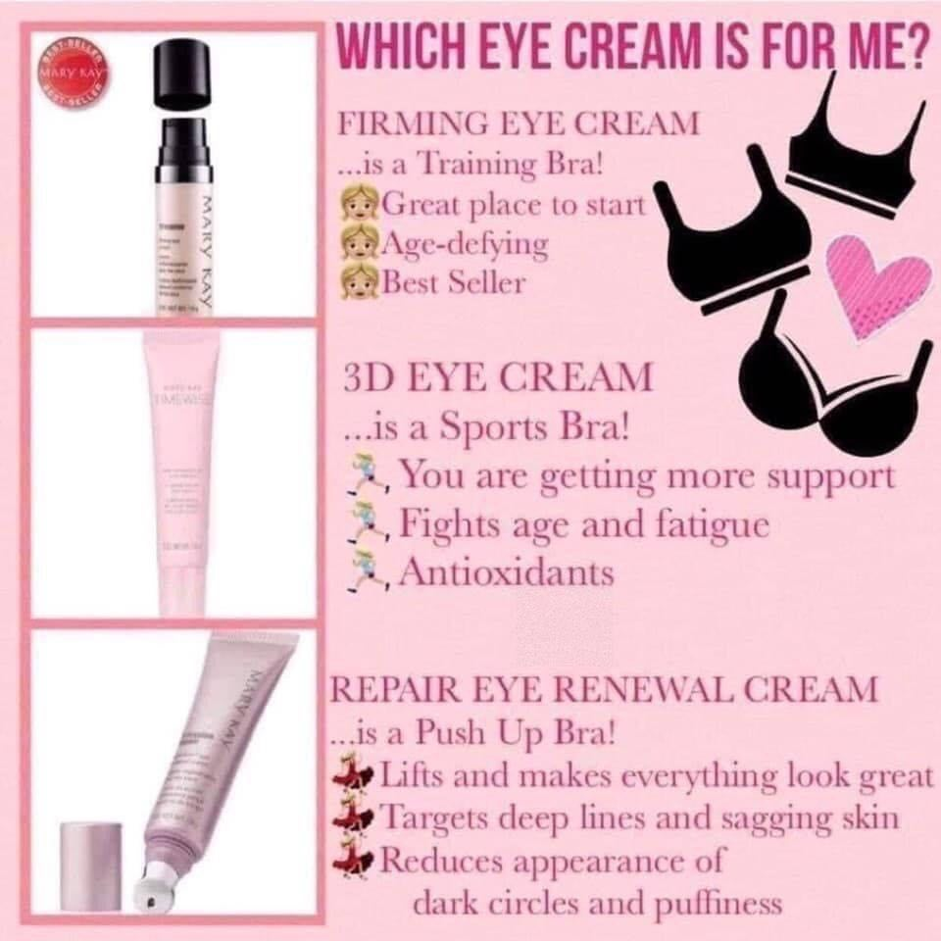

POST 20 –
**PRIZE ENTRY**
Have YOU ever tried our Mary Kay “classic”… the Satin Hands System??
It is a LIFE SAVER especially in these dry winter months… and with all the hand sanitizer lately.
Comment below if you’ve ever tried it or if it might be something to benefit you.
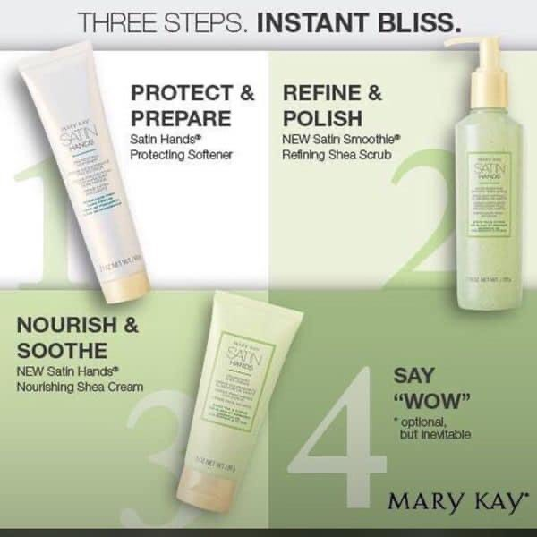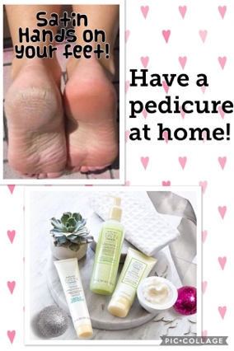

POST 21-
This one’s a SKINCARE SHOWSTOPPER, ladies!
Deep wrinkle filler works immediately by using hyaluronic acid to soften deep lines and retinol to help reverse aging overtime. Immediate AND lasting results!
DOUBLE WAMMY AGAINST DEEP WRINKLES!!
Who could use this power-packed gem in their skincare arsenal??!

That forehead in the first pic is mine and I'm grateful to this product!!! Deep wrinkles be gone!!!

In an 8 week clinical study, 100% of the women showed an improvement in wrinkles!
It significantly impacts the appearance of all 6 wrinkle zones:
1. Forehead creases
2. Between-the-brow creases
3. Crow’s feet
4. Smile lines
5. Vertical lip lines
6. Marionette lines

Retails for $48
It’s a great compliment to any skin care routine, especially our TimeWise Repair system.
Check out the pics below to see it in action!
Deep wrinkles appear to be visibly plumped.
Deep wrinkles are targeted by retinol.
Won’t flake or ball up. Dries to an invisible finish.
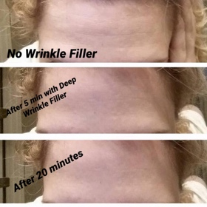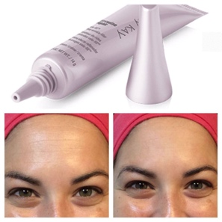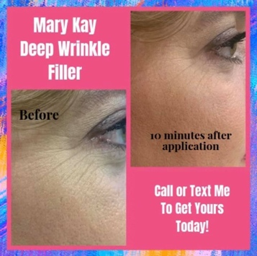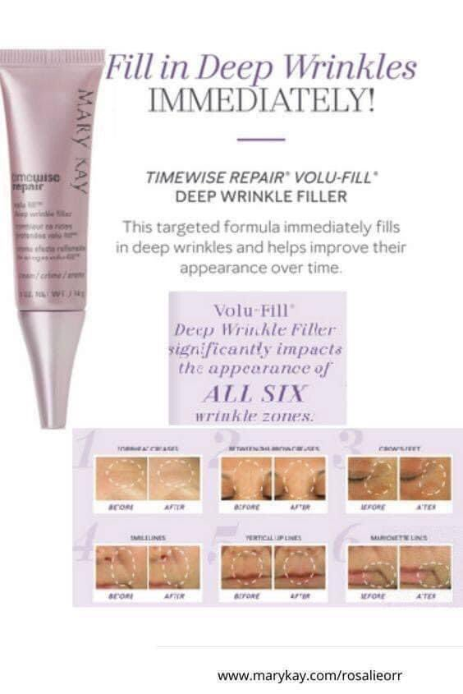

POST 22 –
**PRIZE ENTRY**
Do you remove your eye-makeup every evening?

I used to fight with my eye makeup when it was time for removal, lol. Then I was introduced to THE best eye-makeup removal product on the market. Removes eye makeup so gently – but does the job fully! Plus, it conditions your lashes and is safe for contact wearers (like me)!
It is TRULY the BEST. I PROMISE you’ll fall in love – and if you don’t, you get your money back or can swap for something else you love (that’s the MK guarantee on ALL our products)!

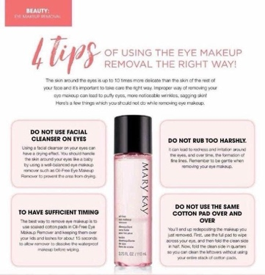

POST 23-
**PRIZE ENTRY**
Which foundation is your preference?
We’ve got something for EVERYONE!
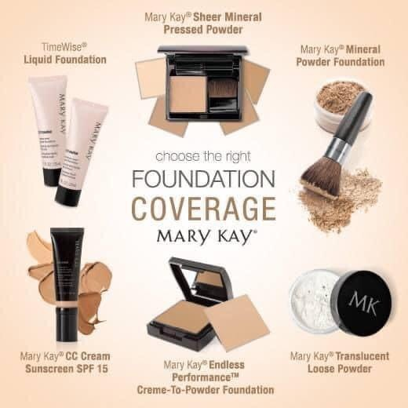

POST 24 –
Let’s talk MASCARA!!
Are you ready for the BIGGEST Lashes you’ve ever seen?
This formula might be my favorite!! DATE NIGHT READY!
Lash Intensity Mascara $18
This is my friend Rachel and she is rockin’ it!!
**PRIZE ENTRY** Post below if mascara is your bestie!!

Magnify. Maximize. Multiply the look of your lashes. That’s intense!
Expand and extend with our only mascara dedicated to multidirectional performance.
With 200% more volume, it’s like adding the thickness of two lashes onto every one; plus, get 84% longer-looking lashes!*
Special Double-Impact™ brush designed to plump while combing through to lengthen the look of lashes.
Mineral-rich, high-impact pigment envelops each lash in a perfect shade of black.

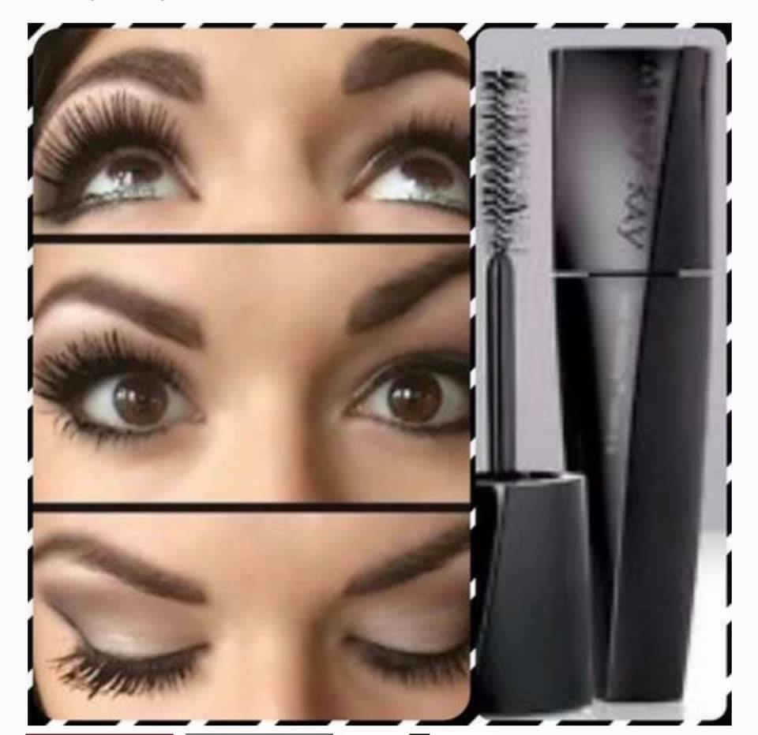

POST 25 –
**LAST PRIZE ENTRY**
***INCLUDES GIFT CARD***
I’d love to set you up with a $5 gift card to use before we even start the LIVE VIRTUAL BEAUTY BASH!!
Simply follow the link below to my website and register by the end of the party!
I’ll do my best to look out for your registration, but to ensure your gift card, just enter “5REG” at checkout and I’ll apply your savings!
Click here:
www.marykay.com/abigailq
POST 26-
I am SO looking forward to our LIVE beauty session tomorrow afternoon!! (Where I’ll give away all the raffle prizes!!)
Set your alarm for: Sunday, Feb 28th at 3:00pm cst!
I want to create the BEST experience for you, so check out the items that you’ll want handy during the session.
Get ready for a half hour or so of “spa time” in the comfort of your home. You’ll be able to see me, but I can see you – so sit back, relax, grab a drink - and get set for some top beauty treatments!

