MASTER your
Virtual Mary Kay World!!!
This document includes successful ideas for: how to stay CONSISTENT with booking through Facebook, the WORDS to say to book, coach, and gain referrals, WHAT to send out after you’ve booked a VIRTUAL session, FB customer group engagement, personal FB posts and MORE!!

Your goal is to connect with women who want or would enjoy a “deluxe pampering packet” AND virtual session to walk through her samples!

WHAT is in the packet?
Beauty Book WITH Beauty Book Set Sheet
Miracle Set 3D
Microdermabrasion set
Charcoal Mask
(Optional Items - include Facial Peel, Gel Mask, Volufirm set [I remove the sleeve to fold], firming eye cream)
PRO TIP: If she is a current customer – add some samples of what she has NOT tried yet.
Facial in a Bag sheet with simple instructions
Business Card/Thank you note
Coupon/Gift Card (optional – you could send a graphic or let her know that you’ll have some great deals for her at her session!)
PRO TIPS:
Outline/Highlight in book what samples you are sending them
Outline/Hightlight on set sheet what samples you sent them
NON Machineable stamp .70 should cover it in a flat envelope
Try to keep samples flat.

Become a BOSS at CONNECTING

HOW do I CONNECT with my FB contacts and friends???

1. Try posting from your personal page about sending out deluxe packs.
Sample post (include picture):
I KNOW there are some stressed out women right now that deserve to take a minute and get some pampering!! Right? 💕😍👌
I’m sending out 30 deluxe pampering packages (my treat… no charge!) straight to your door...does not matter where you live as long as you are in the USA! 🇺🇸 If you would like to claim one, let me know here! 👇🌸
(If you already have a Mary Kay Consultant, please ask her for one🌸)

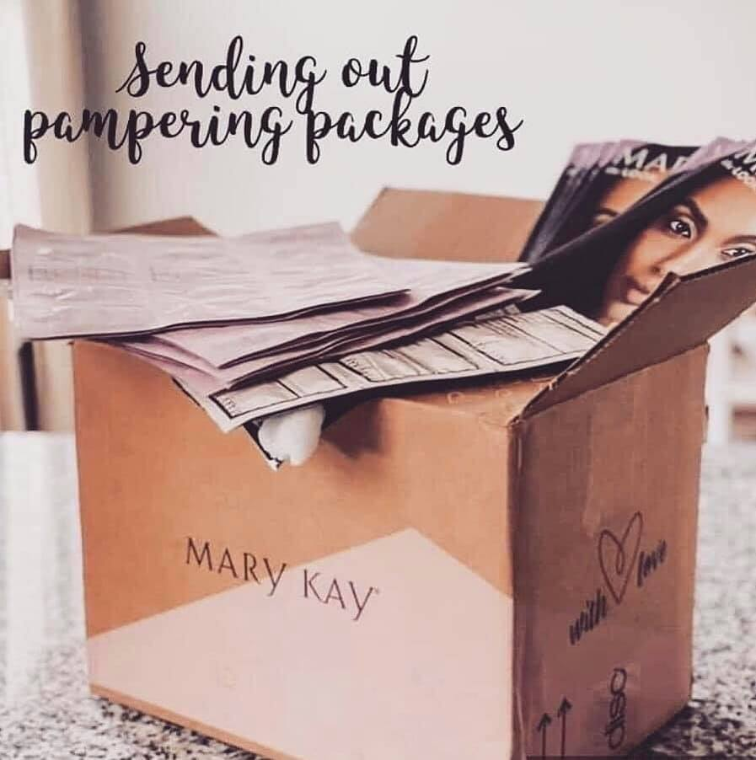
Your goal is to begin engagement and have women respond. Let your MK team/friends know when you are posting and we can comment (not to receive a pampering pack – but to help the post gain popularity so that non-MK friends will see it and have the opportunity to respond/engage).
PRO TIP: Post this in your FB and IG stories as well!!

2. If you don’t want to do a post OR it’s not gaining enough traction OR if you’d like to reach out to more women …
then PM or text this script:

(I personalized it a little) Be real and casual.
----------
Hi Becky! How are you?!

I love seeing your Facebook posts with your kiddos, they are precious!

I hope you are doing well with all the crazy going on in the world!

Also, I KNOW there are some stressed out women right now that deserve to take a minute and get some pampering!! Right? 💕😍👌
I thought of you, because I’m sending out 30 deluxe Mary Kay pampering packages (my treat… no charge!) straight to your door...does that sound fun? I’d love to honor you with one!

Xo,
Adriana

When they say “yes” to the POST or text/pm, here are your responses:

Response #1 Script (for ladies who want a pampering pack):
Hi Christine! How are you? I hope you are well!
I’m so excited to get your deluxe sampler pack out to you!
I customize each bag, so tell me:
1. Is your skin type more normal, dry or oily?
2. Do you have any skin allergies? Allergic to spf?
3. Is there a target area you’d like to change/improve? (undereye circle, uneven skintone, skin softness, overall aging/wrinkles, etc)
4. What’s your best email? And, what’s the best address to send mail to?
Thank you!

Response #2 - After she responds with her info, you say:
Got it! this all looks good, I'll get it all set up to send out and we can set up a time to walk you through how to use it. I usually use ZOOM or FaceTime.

Is it better for us to meet up virtually through a zoom chat on a weekday or weekend?

Then book as usual!

Another Response #2 Option:
Okay, great. I will send you a packet tomorrow... I was wondering, I'm working on building my confidence with VIRTUAL appointments. Would you do a Virtual appointment with me so I could walk you through the products? I usually do Zoom or Facetime? I'll include a coupon for you to redeem after the session? You up for that?

*IF, she is not available to zoom, OR she is a current customer you saw recently in person – please give her the option of attending our next Facebook virtual session!!!

You would say:
We also have the option for you to join our virtual Facebook party where we go through all the samples in a FB live event. Would that be easier?

Then:
Okay great! Our next event is April 16th at 8:30 pm. It’ll run from our “Peek into PINK!” FB group – so I’ll send you an invite now! Did you get it?

Response #3:
I have 2 more packets left. Would you like to tag 1 or 2 girlfriends in the post who may be overwhelmed mommas or women who just need some self-care love to see if they would like one?
(expand your referrals!)
Thank you so much! Is there anything you know you need right now that I can add to your package – no shipping charge and might save you a trip to the store!
*** (try to get a small sale just so it's offsetting the postage).
THIS should get you started! BUT, we ALL know CONSISTENCY IS KEY!!! So here is a GREAT idea so that you can do 5 outreach per day!!!! (without needing to post or take brain space to think of who to reach out to!)

VIRTUAL DELUXE “BIRTHDAY SPA PAKS”
Your goal is to reach out with 5 Deluxe Birthday Spa Paks per day!
HOW? Each day, check whose Birthday it is (through FB).

Look at previous month and days birthdays on FB and add those people to your birthday list
When you run out of Birthdays or don't have enough, start going through your friends list.
Track birthdays in a notebook or put on your google calendar for safekeeping. FOLLOW UP
Set up your Calendly (or old school calendar) and have your scripts ready to copy/paste on your computer or in phone

Scripts for Bday paks:
Hey!!! Happy Birthday!!! I am sending out Happy Birthday Paks to celebrate my friend! I know this may be a little stressful right now, but I want you to know that you are wonderful! Would you like me to mail you a Birthday Pak? My treat, no charge!) Yes?
Okay, great. I will send you a packet tomorrow... I was wondering, I'm working on building my confidence with VIRTUAL appointments. Would you do a Virtual appointment with me so I could walk you through the products? I usually do Zoom or Facetime? I'll include a coupon for you to redeem after the session? You up for that?
Okay, cool... Here is my calendar link so can you set up something for next week? If you can reserve your time today, I can add the coupon to your packet! https://calendly.com/heatherwickstrommk/virtual
Hey, you know what? How would you like to do a Virtual Birthday Party with 3 of your girlfriends? I can send them paks too and we can connect on ZOOM to celebrate you and all do the samples together!!! How does that sound?
Okay, awesome... I think the easiest way to connect would be to make a group message here with everyone and we can all be on the same page and I can send their paks to them... What do you think?

How to create a ROCKIN’ CUSTOMER GROUP FB PAGE!!!

In addition to virtual sessions, you’ll want to stay connected to your customers (current and future) by creating a private Facebook group! Please do so asap if you haven’t already!
Goal is 50 in your Customer Group by end of month -- go through your last 12 month profile cards and add everyone to your fb, then invite them to your group.

TIPS for engagement through your group:
Go live TWICE a week in your group! They want to see YOUR face. I promise!!
Pick two:
Makeup Monday
Tip Tuesday
Wrinkle Free Wednesday
Tutorial Thursday
Favorites Friday
Starter Kit Saturday
(make your Schedule on Sunday)
PRO TIPS:
Choose a product or set and SHOW/TEACH them how to use it!
Thank people who order by tagging them in your VIP group. Recognize your customers for how amazing they are.

Other engagement ideas for customer group.
TWICE a week – post something NON-MK
Ideas:
Good news posts! (like hand sanitizers making it to first responders)
Opinion polls! People LOVE to give feedback and it creates engagement from customers so that they see the other MK posts you do in the group. (this applies to your personal page too).
Start a post where everyone posts a pic of their “Furr babies”!
Get to know THEM through the posts. This allows for more opportunity to relate and connect!

Other PRO TIPS while in Quarantine!
CAUTION! These are ONLY for use if you want to move up and expand your business!

Check in with 3-5 Customers/Friends by call or text to see how they are doing during this quarantine time.
MKU-- have you completed all the sessions?
Are you familiar with MKU on our www.thefireunit.com website?
Sell 25 items/week TRACK this
When someone orders ANYTHING, always offer 1 more item 30% off... suggest higher priced items. If mailing then consider the weight so your discount matches the weight of the package.
Share your monthly goal with your director!! What bill do you want to pay this month? How do you want to impact your freedoms and choices with your MK?
Ask 5 people to do the foundation quiz on your website. Have you done it? Match yourself.
Text your Director your progress by Wednesday and Saturday each week.
Set up 2 facetime interviews to be held this week. Have them fill out the survey first, then interview them.
Script:
Hi Susie! How are you? I hope you are well during all this quarantine crazy!
I had a quick question for you… do you have a minute?

Then:
Great! You know how much I love my MK biz (thank you for being such a big supporter)! And with the extra time at home, I’m working on my leadership skills. Would you be open to a 15 minute call to help me move forward on the leadership path? (I know your time is precious, so you’ll be getting a gift card just for your time!)

Zoom, Mailer and Instruction Guide Details!

ZOOM SIGN-UP DEETS!

If you’d like to use ZOOM, there is a free version, but it cuts off at the 45 minute mark. If you’d like to pay for unlimited time, use this link for $10 per month:

https://workinglive.us/sign-up

passcode: workinglive

FOLLOWING sign up, check email; click to confirm their $10 offer acceptance.

(if you already have zoom, you’re most likely paying $14/month. If you’ll sign up with this link you’ll keep your exact same account but for $10.

In addition to ZOOM, Calendly is also a great option for organizing your calendar and booking opportunities! You’ll be able to create a link for customers to choose their session time from!
Visit Calendly.com for details!

MAILER OPTIONS:
200 pcs Blue Chevron Paper Gift... https://www.amazon.com/dp/B00K325FZU?ref=ppx_pop_mob_ap_share https://www.amazon.com/dp/B00K325FZU?ref=ppx_pop_mob_ap_share

For FB Events – an optional instructions guide:
https://drive.google.com/file/d/1HbABHLjN4if5ZdYFSp-0mxx1LLieL8sp/view?usp=drivesdk

Deluxe Pampering Set Instruction Sheet:
SEE NEXT PAGE

DELUXE PAMPERING PACK INSTRUCTIONS
GET READY TO FEEL FABULOUS!
Charcoal Mask:
Tear open packet of Charcoal Mask.
Apply with finger or brush to your T zone, oily, or acne areas of face.
Allow mask to dry.
Once dry, remove with a warm, wet washcloth by pressing to dampen then wipe away.
Rinse the washcloth with hot water and put aside for next step—keeping the cloth WARM.
Timewise Age Minimize 3D 4-in-1 Cleanser
Open Cleanser Packet. Squeeze all of the contents and apply to the entire face (avoiding eyes).
Microdermabrasion Refine
Open Refine packet and squeeze all of the contents ON TOP of the Cleanser. Using the pressure of your fingers move the crystals around in small circles all over your face (avoid eyes).
Apply WARM Washcloth over face and drape over face, put your head back and relax. As the cloth cools down, remove all products from your skin. You may need to rinse in your sink at this time and pat dry to remove all of the crystals.
Timewise Pore Minimizer
Tear open packet and apply to your skin.
Timewise Age Minimize 3D Eye Cream
Open the EYE CREAM packet and use your 4th or 5th fingers to apply under and over your eyes.
TimeWise Age Minimize Night Cream:
Open the Night cream packet and apply all over the face. (avoid eyes)
TimeWise Age Minimize Day Cream:
Open the Day cream packet and apply all over the face. (avoid eyes).

THANK YOU FOR EXPERIENCING THESE BEAUTY TREATMENTS WITH ME!
You are amazing and I appreciate you!

