Dacia Wiegandt, Senior National Sales Director
- Started her Mary Kay career:
  - July of 2001
  - Just 6 months later she debuted as a Sales Director
- Has earned 10 cars
  - 6 being the prestigious pearl Cadillac
  - Currently drives the pearlescent pink, Escalade
- In 2004-
  - Dacia & her unit achieved the Million Dollar Circle of Excellence
  - Dacia became the youngest Million Dollar Sales Director in MK history
- Has earned over 40 carats in DIAMONDS!
- Traveled Mary Kay style to:
  - San Francisco, CA
  - Maui, Hawaii (3)
  - Greece (2)
  - Crete
  - Copenhagen
  - Sweden
  - Russia
  - Austria
  - Australia
  - England
  - Cruised the British Isles & Channel Islands
  - Italy
  - China
  - London
  - Spain
  - Argentina
- Has 60 Area Sales Directors and a NEW N.S.D. offspring, Auri Hatheway.
  - Highest love check in one month = $60,000.00
  - She is an official Mary Kay Millionaire—having earned over $4 Million in commissions
  - Proud of her husband Karl & their three children
    - Austin 12, Mason 10, Addison 7
- She is very thankful that Mary Kay has provided her with the flexibility to be a stay-at-home mom while also making an executive income.
- Dacia Loves the philosophy of Mary Kay
  - Faith first
  - Family second
  - Career third
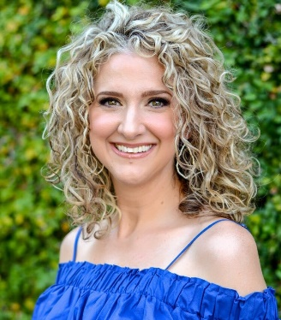
Abigail Quinn, Senior Sales Director
- Started Mary Kay Career:
  - January 2002
  - Put MK Career on hold to teach High School for 7 years
  - Started back consulting with Mary Kay in March of 2012
  - Debuted as Director October 2012
  - Senior Sales Director with 2 First line Directors – Trish Villarreal and Sydney Kuehler
- Earned 5 MK Cars
  - 2 being the prestigious pearl pink Cadillac
  - Currently driving the pearl pink Cadillac
- Awards:
  - 9 Time Gold Medalist
  - Area Miss Go Give 2016
  - #1 Unit in the DARE Area (currently)
  - Highest Commission Check = Over $11,000
  - $450,000 Circle of Achievement
  - #1 in Debuting Director Class
  - Fabulous 50s, On the Move and Honors Society Achiever
  - Queens National Court of Sharing 2014, 2017, 2018
- Fun Facts about Abigail:
  - Family: Husband, Shawn; Daughters, Sarah (7), Rebekah (5), Hannah (3)
  - Prior Occupation: High School Social Studies Teacher
  - Hometown: Granbury, Texas
  - Lives in: Avon, OH
  - Hobbies: spending time with family and friends, shopping, reading, & watching the Hallmark channel. 😊
  - Favorite Movie(s): The Count of Monte Cristo and Overboard
  - Favorite Bible verse: Romans 8: 38-39
  - Favorite Quote: “You can have big dreams, but you must understand that your long-term successes are a direct result of what you achieve every day.”

